LEWIS & CLARK TIGER DRAMA

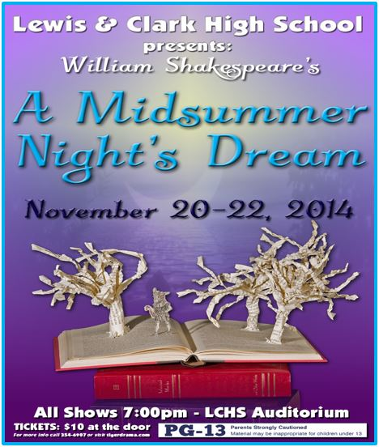

WWW.TIGERDRAMA.COM
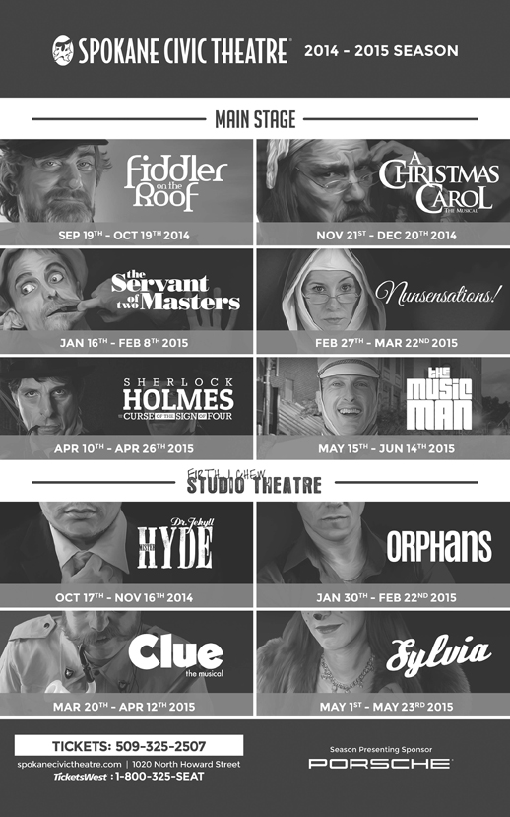
FROM PAGE TO STAGE
Finding the Power in the Process

Our 2014-2015 Tiger Drama Season theme is ‘From Page to Stage: Power in the Process’. This theme has been adopted by the entire LCHS Fine and Performing Arts Department. Along with our symphonic band and orchestra, we are the first high school in the country to bring the E.B. White classic children’s novel The Trumpet of the Swan to life this December. Our choir will musically explore Shakespeare’s sonnets in coordination with our production of A Midsummer Night’s Dream. The visual art department will literally and physically use books as a basis for new works of art.

We are exploring how a theme can be presented thematically through subject matter, but also through physical, visual, and scenic elements as well. We will be using and adapting scenic elements from each of this season’s shows to evolve with our theme running throughout the season. Things that appear in one show will transform to become something new in the next. We are also exploring how characters interact with the text in a variety of ways: literally, metaphorically, and visually.

Perhaps the most exciting element of following the process of material going from page to stage is the creation of a world premiere musical: Kelly the Destroyer vs. the Springfield Cobras. This production is being created by our Musical Theatre class working with composers Rob Hartmann and Katie Kring. Work on this show began last spring when students auditioned knowing nothing more than the title of the show. Over the summer, Rob and Katie worked to create a structure/framework for the production. This fall, the collaboration began. Students have been involved in forming their own characters, tracing themes in education and offering input on the complex issues they confront as they prepare for life beyond high school. Having students be part of creating a new work has been exhilarating and daunting but a challenge that has forced us all to realize the vast amount of skills and talents necessary to create a new work. Time management, collaboration, creative and critical thinking, perseverance and resilience are just a few of the skills taught, practiced and refined in the process of bringing each of the shows this season to life.

REVISIT OUR PAST SEASONS AT www.tigerdrama.com

LEWIS & CLARK

TIGER DRAMA

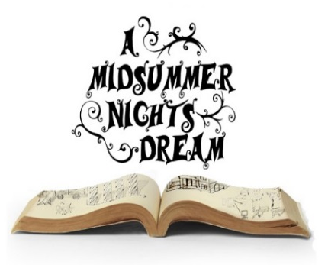
Suzanne Maguire – Director
Choreography – Holly Edwards

Chloe Forsberg | Ilan Hernandez
Julian Lee | Jackson McMurray

By William Shakespeare

with

Tristan E. Bolen | Jillian Burgess | Noel Benjamin Case
Tyese Chumov | Holly Edwards | Cori Gillis
Tailer Englehart-Grotte | Bailey Heppler | James Hogstad
CaraLee Howe | Emma Kraby | Iaine Rex MacKay
JJ (Justina) McDirmid | Grace Pacholczak | Megan Rosenau
Liam Schaaf | Hannah Summers | Grant Thayer
Victoria Whiteaker

Lighting Design | Poster Design | Costumer
Greg Pschirrer | Anna Maguire | Lisa Caryl
Program Design | Headshots | Scene Design/Construction
Theresa Meyer & Suzanne Maguire | Scott Martinez & Richard Maguire | Stagecraft Class & Bailey Heppler

ABOUT THE DIRECTOR

Suzanne Maguire (Director) holds a Bachelor’s degree and Secondary Education Certification in Speech Communication and Theatre from Northern Arizona University. MSND is the first Shakespeare production she's directed and she's grateful to Mr. Pschirrer for the challenging opportunity. For another Tiger Drama season of support and participation, she is ever grateful for her wonderful husband, Richard and kids (Brennen, Anna & Elliott)!

ABOUT THE STAGE MANAGERS

Beth Lambert (Class of 2016) is excited to assistant stage manage her first LC production and experience a show from this new perspective! She previously appeared in LC’s Thoroughly Modern Millie. She is planning on earning a degree in Musical Theatre and hopes to someday perform on Broadway. She would like to thank her friends and family for their love and support.
Melina Palomba (Class of 2015) is thrilled to have the opportunity of being a stage manager. Her previous appearances include Thoroughly Modern Millie, Seussical, and in The Little Mermaid. She has enjoyed her time in the LC Theatre Department and plans on attending Gonzaga University next fall. She thanks Beth Lambert for being such a great assistant stage manager.
TIGER DRAMA DATES

Dec. 1-4 Dress Rehearsals - Trumpet of the Swan
Dec. 5-6 Trumpet of the Swan
Dec. 8-10 Auditions - Into the Woods
Jan. 7 IE Thespian Showcase
Jan. 10 Thespian Adjudicator Training
Jan. 17 IE East Festival at LCHS
Feb. 17-19 & 23-25 Dress Rehearsals - Into the Woods
Feb. 26-28 & March 5-7 Into the Woods
March 19-21 State Thespian Festival - WWU - Bellingham
April 20-23 Dress Rehearsals - Kelly the Destroyer
April 24-25 Kelly the Destroyer vs. the Springfield Cobras
May 11-12 Auditions - Closing Night
June 2-3 Dress Rehearsals - Closing Night
June 4 Closing Night
June 5th Ave Awards - Seattle

Stay updated on everything that is going on at LC!

Visit
www.lctigers.com

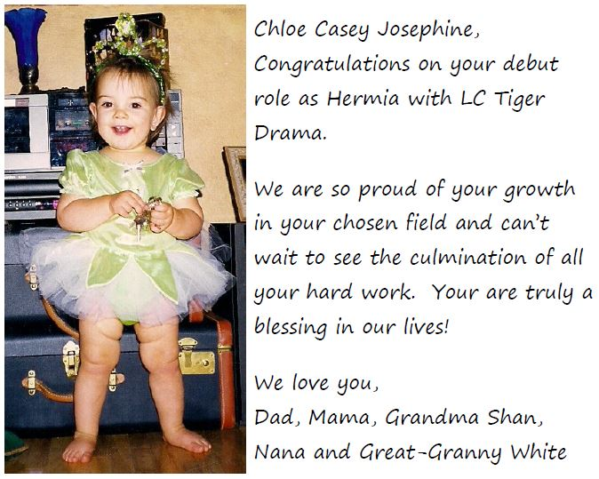
DIRECTOR’S NOTES

As we planned our “Page to Stage: Power in the Process” season, we knew a Shakespeare had to be included. After all, William Shakespeare is one of the greatest playwrights that ever lived and the process of bringing one of his plays from page to stage is an incredible learning experience for everyone involved. Having never directed Shakespeare before, I was very hesitant in my ability but with the great support of Greg Pschirrer and amazing, hard-working talented students working on cast and crew not to mention other supportive adults and family members, I think we have pulled it off!

The process of learning and living a classic and famous work like “A Midsummer Night’s Dream” is daunting at the very least. These young actors have embraced the challenge and risen to the occasion and I am very proud of all of them. I would be remiss if I did not note a few of the valuable skills developed and honed over these last six weeks: time management, collaboration, creative thinking, historical research, designing, problem solving, dance, projection, articulation, memorization, and following directions. Our goal this season is that our students and our community will realize the tremendous value that arts education brings to those who participate and how the experience grows students in abilities that transfer to many other areas of life! We hope you enjoy your part of the process as an audience member as much as we have enjoyed the process of creating it.

SPECIAL THANKS

Rex Forsberg | Richard Maguire
Ellicia Elliott | Scott Martinez
Chad Brazill | Lynda Tschabold
Pauletta Caryl | The Schaaf Family

CREW

Stage Manager....................................................................Melina Palomba
Assistant Stage Manager..........................................................Beth Lambert
Props...........................................................................Micaela Ackermann,
......................................................................Bethany Daniel, Celeste Gray*
Bottom’s Head Construction..................................................Bailey Heppler
Flys...............................................................Sam Dunlap, Isabella Weiand*
Lighting Tech........................................Zynobia Cimarrustti*, Patrick Lynch
Sound Tech..................................................Emma Lyons*, Anissa Martinez
House Manager................................................Breezy Desormier, Brie Cole*
Hair and Makeup....................................................Olivia Davis*, Mia Hunt,
...........................................................................................Christian Haberman
Costumes..............................................................Miranda Anthony-Miller
Costume Construction................................Hannah Summers, Emma Kraby,
............................................................Stacy Kraby, Cassie & Jason Heppler
.....................................................Madison Leeds, Pauletta Caryl, Lisa Caryl
Ushers..............................................Anna Maguire, Brittany Mendoza-Pena
......................................................Kezia Rhodes, Dominick Betts, Will Petro

* indicates crew lead

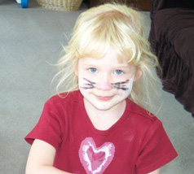
Our Sweet Senior,

From kitties to birds, we've always enjoyed your special talents! Break a leg in the swansemble!

Love, Your family fans
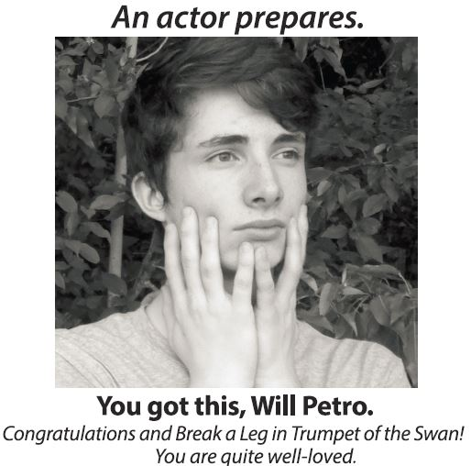

Jules,
You've been entertaining us for years! We are excited to hear your Shakespearean lingo!
Love,
Dad, Mom, Jordan, Brendan, Lindsay, Ryan, & Lucy

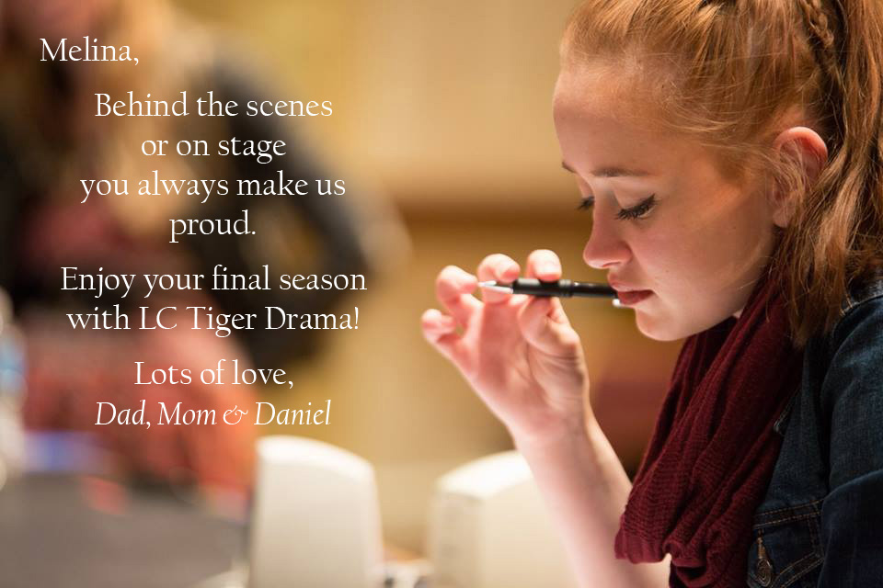
WHO’S WHO IN THE CREW

Micaela Ackermann (Class of 2018) has appeared in multiple productions with various theatres including SCT, CYT, MCT, TAC, and Coeur d'Alene Summer Theatre. She also studies voice with Brad Perry and plans to go to Berkeley, UCLA, CSULB, or the University of Utah and major in theatre.
Miranda Anthony-Miller (Class of 2018) is assisting with the rest of the crew for the first time. She hasn't had performances on stage before, but enjoys helping backstage. Although she doesn't appear on stage, she loves the theatre and often makes videos in her spare time. She hopes to continue to participate in theatre throughout high school.
Brie Cole (Class of 2015) She recently appeared in Gypsy (June) at Spokane Civic Theatre, and LCHS’ Seussical (Bird Girl), Noises Off (Brooke), and Thoroughly Modern Millie (Dorothy Parker). Brie spends her free time taking voice from Ben Bentler and ballet from Tamara Zink at Artistry in Motion. She thanks her wonderful parents for their support (and funds) of her theatre life!
Bethany Daniel (Class of 2018) is delighted to be involved in her first Tiger Drama Production. She has been involved in theatre since a very young age and can’t wait to become a part of the Tiger Drama Family.
WHO’S WHO IN THE CREW

Breezy Desormier (Class of 2017) is excited to branch out and participate in her first Tiger Drama production. She plans on attending the University of Washington majoring in Diagnostics and Therapeutic Instruments. She thanks Pschirrer and Maguire for allowing her to have this wonderful opportunity.
Celeste Gray (Class of 2015) is delighted to be a part of the crew of her first show at LC. Though she possesses little experience with theatre, she has always come to the shows and is excited to finally have the opportunity to be a part of one! She would like to thank her theatre friends for welcoming her into their world and allowing her to be a part of Tiger Drama!
Christian Haberman (Class of 2016) is excited to be on the costume crew for his first LC production. He enjoys dancing, doing makeup for photo shoots, and plans on going to Cinema Makeup School to become a Hollywood makeup artist.
Mia Hunt (Class of 2016) is ecstatic for her first production. She is really excited to work with LC Tiger Drama.
WHO’S WHO IN THE CAST

Hannah Summers (Class of 2018) participates in the LC Tiger Drama Club and enjoys playing tennis and relaxing with friends. Although this is her first show at LC, she has been in productions of I Never Saw Another Butterfly and Our Town and was a student director for the Sacajawea drama club. She is excited to be involved throughout her high school years.
Grant Thayer (Class of 2015) is in his first year of performing arts. In his free time, he loves to golf and spend time with friends and family. He plans on attending EWU and major in Business Administration with a minor in Finance. Grant would like to thank his family, friends, Pschirrer and Maguire for tons of help and support throughout the whole process.
Victoria Whiteaker (Class of 2015) has been involved in Tiger Drama for all four years, and has been on crew for four shows. This is her first non-musical play at LC. In addition, she has been to the Inland Northwest Theater Arts Festival, and attended the National Thespian Festival Lincoln Nebraska. She would like to thank her mother and grandparents for their continued support.
WHO’S WHO IN THE CAST

JJ (Justina) McDirmid (Class of 2018) has been acting with Civic Theatre and was the leading role in The Best Christmas Pageant Ever. She plans on continuing in the Drama department, and also wants to start film and photography. JJ would like to thank Pschirrer, Maguire, and everyone else who has supported her throughout this wonderful journey!
Grace Pacholczak (Class of 2017) is an outgoing 15 year old who enjoys painting, drawing, making videos and acting. This is Grace's first big show that she has ever been involved in and she looks forward to being involved more with the LC Drama program.
Megan Rosenau (Class of 2016) her appearances include Thoroughly Modern Millie, Peter Pan, School House Rock, and Alice. Megan is on the LC Drill Team and enjoys dancing in her free time. She dedicates this performance to her supporting family, Maguire for the amazing opportunity, and her best bud Jules.
Liam Schaaf (Class of 2015) is excited to be appearing in his fourth full-length LC production, after playing Thoroughly Modern Millie (Ching Ho), Noises Off (Tim), and Seussical (Vlad Vladikov). He plays on the LC Knowledge-Bowl team, and has participated in Opening Night for the last two years. He would like to thank Pschirrer and Maguire for teaching him everything he has learned about theatre.
WHO’S WHO IN THE CREW

Patrick Lynch (Class of 2017) is excited for his first year with the Tiger Drama Department. He is in Drama 1 and Stagecraft and is excited to be on crew.
Emma Lyons (Class of 2016) has previously been seen performing on the LC stage in Seussical (Thing 2), and designing lights for Seussical and Noises Off. She thanks her mom for her dedication to her success, and to Pschirrer, for teaching her most everything she knows about technical theatre.
Isabella Weiand (Class of 2014) has been working on crew for three years including LC’s The Little Mermaid, Thoroughly Modern Millie, and Noises Off! She is excited to be part of another LC production.

Cast Headshots by Scott Martinez

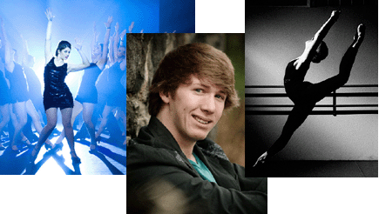
Also available for weddings & senior portraits.
www.scottmartinezphotography.com

Please visit our instrument "petting zoo" in the lobby during The Trumpet of the Swan. Young concertgoers can get up close and hands-on with the instruments they'll see played on the stage--from violins, trumpets, and oboes to trombones and percussion. Special thanks to Hoffman Music for their support of this educational opportunity.
Hoffman Music
1430 N Monroe Spokane WA 99201
509.444.4140
www.hoffmanmusic.com
WHO’S WHO IN THE CAST

Emma Kraby (Class of 2018) is a competitive gymnast with a club team and the LC gymnastics team. She also enjoys tennis, golf, and playing the violin and piano. This is her first LC theatre production, but she looks forward to participating in many more.
Julian Lee (Class of 2016) her previous LC shows include Noises Off, The Dining Room, and Seussical. She enjoys writing songs for guitar and creating short films. She would like to thank Mrs. Maguire and Mr. Pschirrer for all the time they've put into helping her grow as an artist. To her family and best friend Megan: thank you so much for your unending support!
Jackson McMurray (Class of 2015) is appearing in his second LC show after Thoroughly Modern Millie. He has been trained in physical and Basel mask theatre and dedicates his performance to his former teachers at the Vancouver School of Arts and Academics, who taught him to love Shakespeare.
Iaine Rex MacKay (Class of 2018) is proud to be in his first production at LC. He has acted in a retelling of Tom Sawyer (Injun Joe). Iaine enjoys playing music and reading, and plans on studying abroad in Britain or attending BYU. He dedicates his performance to Mike Cantlon, his most treasured teacher.
WHO’S WHO IN THE CAST

Bailey Heppler (Class of 2017) has been heavily involved in theatre both onstage and off for several years. This is Bailey's first LC production and she is thrilled to work with such a talented group of people. She would also like to thank Maguire for this incredible opportunity.
Ilan Hernandez (Class of 2016) his LC productions include: In the Heights, The Dining Room, Thoroughly Modern Millie, and The Little Mermaid. Special thanks to Maguire for making his Shakespeare dream come true and to Tamara Zink for her invaluable encouragement and training. He is blessed by his family’s love and support.
James Hogstad (Class of 2016) is elated to be in his first Shakespearean play! He has previously appeared in LC’s Thoroughly Modern Millie (Kenneth) and Legally Blonde (Elle's Dad/Winthrop/Sundeep) at Spokane Civic Theatre. He thanks Pschirrer and Maguire for this opportunity and to all his cast mates for the memories.
CaraLee Howe (Class of 2016) appeared in LC’s Thoroughly Modern Millie and Seussical and I Never Saw Another Butterfly at TAC and Vanya and Sonia and Masha and Spike (Nina) at Ignite. She thanks Pschirrer and Maguire for this amazing opportunity and for all they do. She dedicates this performance to her friends and family for their support.
Do you want to place an ad in an upcoming LC Tiger Drama Playbill that will be seen by nearly 3,000 people? These can be ads for a local business or even good luck wishes with family or baby pictures from family members and friends.
SOLD OUT for entire season!
Ad sizes available:
- Outer Back Cover Full Page - $200.00 (full color ad)
- Inner Front/Back Cover Full Page - $100.00
- Inner Full Page (4.5" x 7.5") - $75.00

Half Page (4.5" x 3.75") - $50.00

Business Card (4.5" x 2.5") - $30.00

Payments can be sent to:
Lewis and Clark High School
attn: Greg Pschirrer
521 W. 4th
Spokane, WA 99204

Ad copy/images – send to:
theresam@spokaneschools.org
PLOT SYNOPSIS

Shakespeare’s original script takes place in 5 acts. We combine the first 3 acts to create our Act I and the last two acts are our Act II. The Oregon Shakespeare Festival adaptation by Hilary Tate cuts sections of dialogue in order to make the show shorter while still maintaining all significant plot points and characters.

This image, sadly, not credited on the internet, was found by one of our parents early on in the process. I think it gives a much better plot synopsis than I could ever write. And, William Shakespeare never fails to give his comedies the most happy of endings so, never fear - despite the confusion - “all shall be well”.

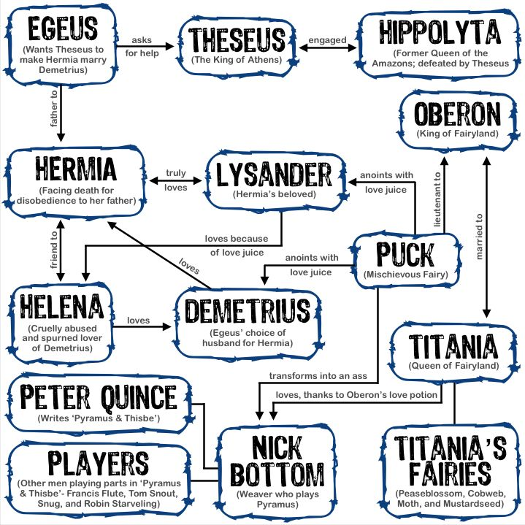

WHO’S WHO IN THE CAST

Holly Edwards (Class of 2015) is excited to be a fairy and is honored to be given the opportunity to choreograph the dances in the show. She appeared in LC’s Thoroughly Modern Millie, and stage managed Noises Off. She's happy to be a part of such a lovely show, and thanks her wonderful directors for this opportunity. She dedicates her performance to her dad.
Cori Gillis (Class of 2017) has sung with the LC Choir for the past two years and is excited to be in her first Tiger Drama production! She would like to thank Maguire for this awesome opportunity, and all of her "sons" for supporting her.
Tailer Englehart-Grotte (Class of 2016) is excited to be in her first Tiger Drama production! She has also appeared in I Never Saw Another Butterfly (Child 3) and Bye Bye Birdie (Deborah Sue) at Theater Arts for Children. She thanks her family for all the love and support.
Chloe Forsberg (Class of 2016) is ecstatic to be cast in her first play! She performed in Opening Night and Closing Night last year, and assistant stage-managed Noises Off. She is looking forward to Stage Managing Into the Woods this year, and would like to thank Pschirrer and Maguire for this opportunity! She thanks her family for their support and driving her where she needs to be!

WHO’S WHO IN THE CAST

Tristan E. Bolen (Class of 2015) is new to LC, but previously performed in multiple shows including Juvie and I Never Saw Another Butterfly. He plans to receive a Master’s degree in Theatre. Tristan would like to thank his teachers and friends for always being there for him. "You've become my true family."
Jillian Burgess (Class of 2015) appeared in Opening Night, Seussical Jr. and Closing Night and has also been involved with the Spokane Civic Theatre's summer programs. She has been on crew for large amount of LC’s The Little Mermaid, In the Heights, Thoroughly Modern Millie, and Noises Off. She cannot wait to continue her last year at LC with such an incredible group of kids.
Noel Benjamin Case (Class of 2018) is an active participant in school drama and has moved to Spokane recently. He has appeared in several productions including Shrek the Musical (Shrek) in Saratoga Springs, New York. He also enjoys playing music and being creative in his spare time as a young artist.
Tyese Chumov (Class of 2016) has been involved in the drama program since freshmen year and is grateful for the experience behind the scenes in all the productions she has worked on. She is excited to have this opportunity to appear onstage. She thanks her siblings for their support and her parents for pushing her to pursue her dreams.
ACT I

Scene 1 – The estate of Duke Theseus, several days before his
wedding
Scene 2 – The home of Quince, leader of the merry band of players
Scene 3 – A forest outside Athens
Scene 4 – The forest, later that night
Scene 5 – Even later, in the forest

ACT II

Scene 1 – Early morning, Titania’s bower in the forest
Scene 2 – Another group enters the forest
Scene 3 – Quince’s home in Athens
Scene 4 – Theseus’ home in Athens, the day of the wedding
Scene 5 – Late that night- Theseus’ estate home

Special Music for Fairy Dances:
- "Us and Them"- by John Lunn from “Downton Abbey”
- "Dawn"- by Dario Marianelli from “Pride & Prejudice”
JOIN US FOR OUR 2014-2015
FROM PAGE TO STAGE SEASON

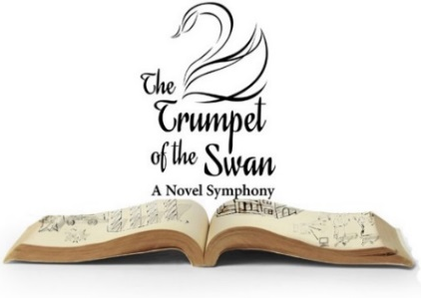 | December 5-6  7:00pm
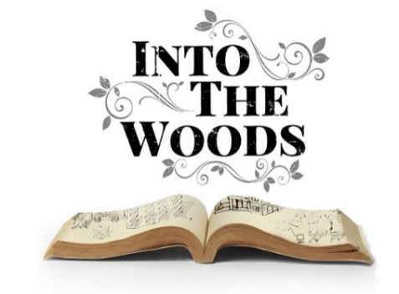 | February 26-28  &  March 5-7  7:00pm
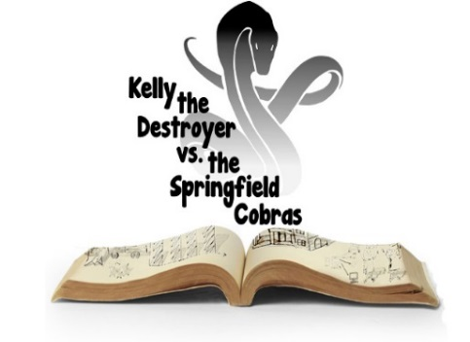 | April 24-25  7:00pm
CAST
In order of appearance

Philostrate...............................................................Tailer Englehart-Grotte Theseus...............................................................................James Hogstad
Hippolyta.............................................................................CaraLee Howe
Egeus.....................................................................................Iaine Mackay
Hermia................................................................................Chloe Forsberg
Demetrius...........................................................................Ilan Hernandez
Lysander........................................................................Jackson McMurray
Helena........................................................................................Julian Lee
Quince.................................................................................Tyese Chumov
Flute..............................................................................Victoria Whiteaker
Bottom.....................................................................................Liam Schaaf
Starveling..............................................................................Jillian Burgess
Snout..........................................................................................Noel Case
Snug......................................................................................Grant Thayer
Puck....................................................................................Bailey Heppler
Fairies.......................................................Holly Edwards (Dance Captain),
.............................................................................Cori Gillis, Emma Kraby,
...................................................................JJ McDirmid, Grace Pacholczak,
.......................................................................................Hannah Summers
Oberon...................................................................................Tristan Bolen
Titania................................................................................Megan Rosenau
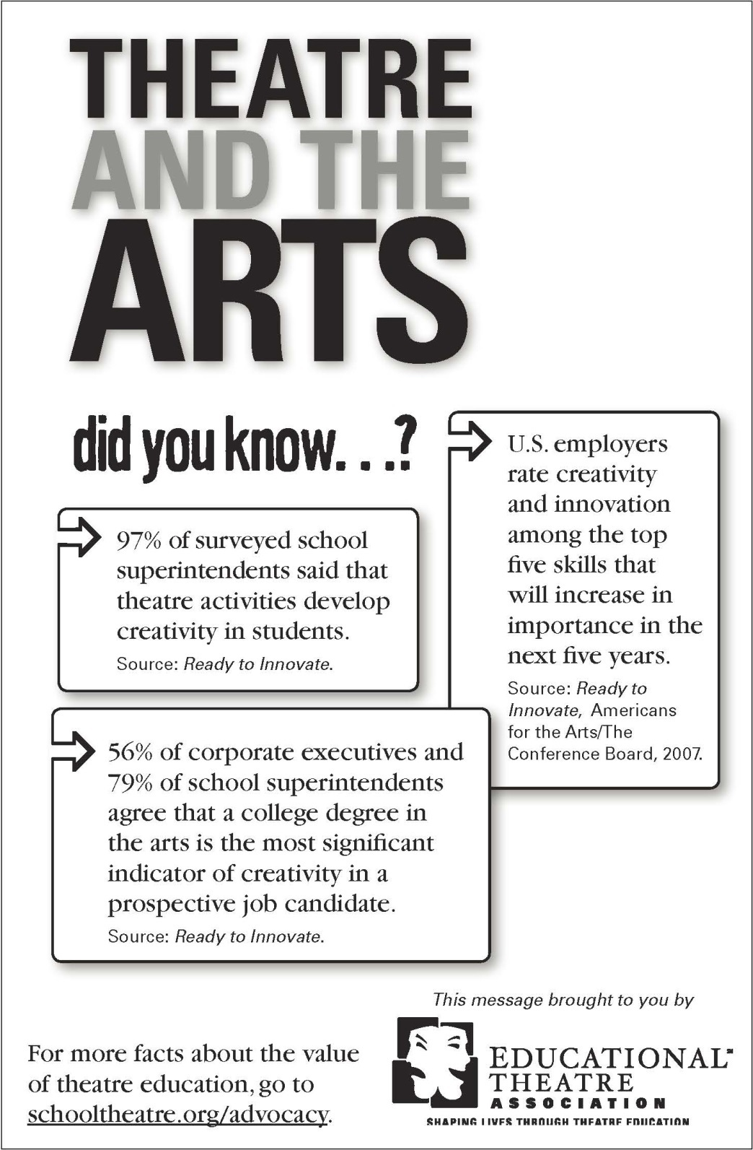
STAGE

MISSION STATEMENT

STAGE's activities may include providing funding for the theatre program as needed for supplies and services not covered by the District as well as scholarships to be given to those students whose families are unable to pay for competition travel expenses and such other items needed to participate fully in the theatre program. STAGE may also support and encourage all theatre students in their theatrical endeavors by supplying chaperones to all school-sponsored, off-campus competitions and performances. STAGE’s goals are to promote and foster clear, concise and timely communications between the Theatre Director, the Board of Directors and parents/guardians of all theatre students.

Last year, donations of time and money have provided:
- assistance paying for charter busses for State and 5th Avenue
- scholarships for student production packs
- volunteers for ticket and concession sales
- assistance at cast parties organizing and chaperoning
- organization of season t-shirt sales
- design, materials and labor for our award-winning “Outstanding Lobby Display” for In the Heights

If you are interested in more information or would like to be on our email, please stop by our table in the lobby! Thanks for your support!
