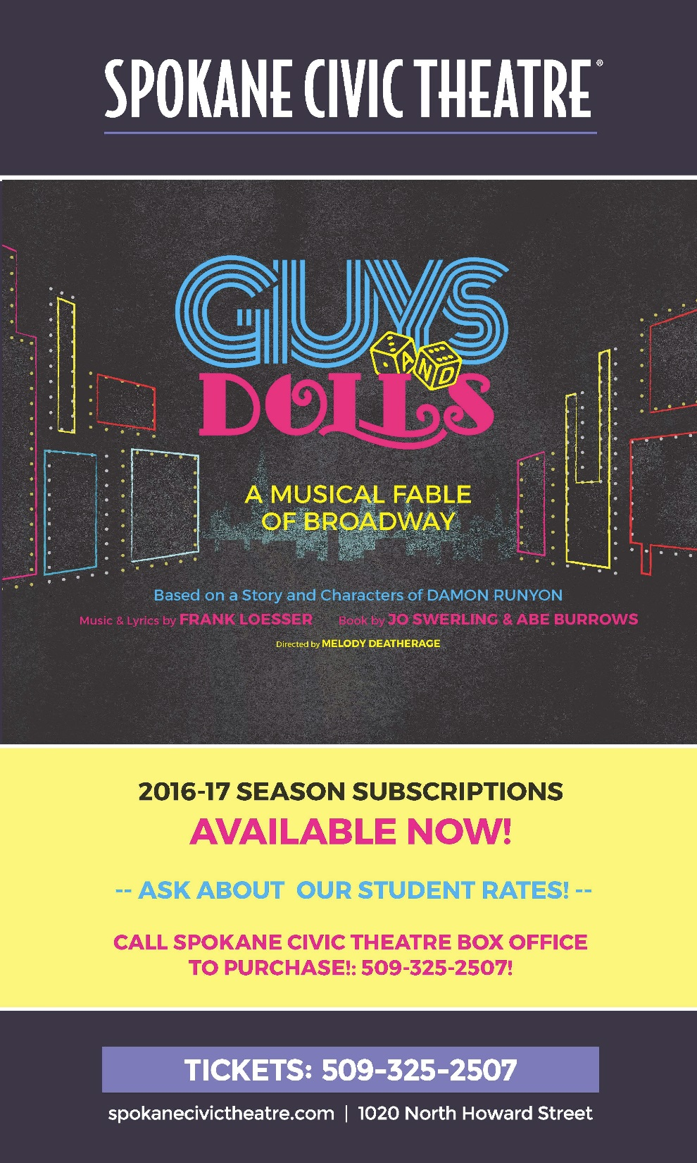

LEWIS & CLARK TIGER DRAMA

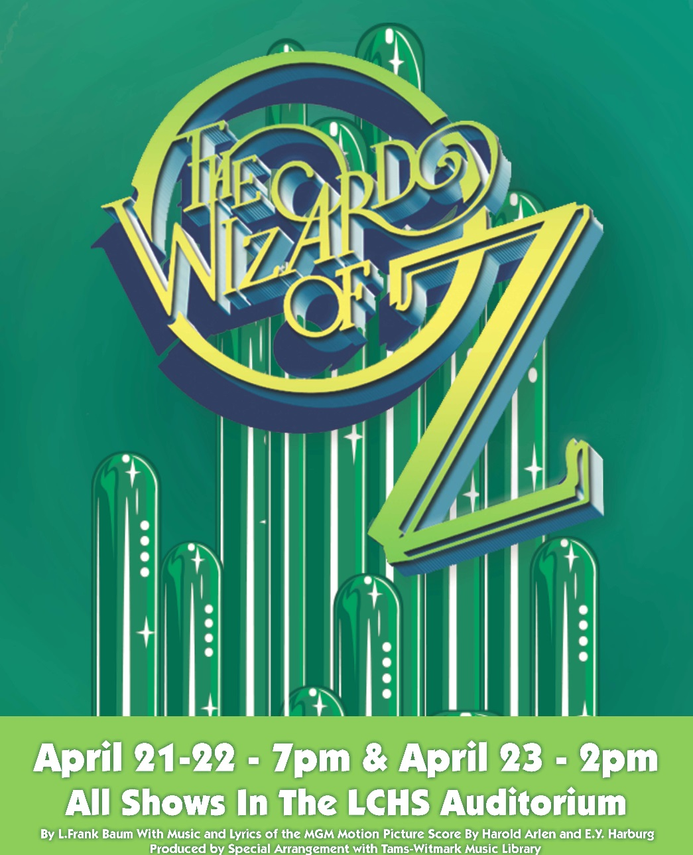

WWW.TIGERDRAMA.COM

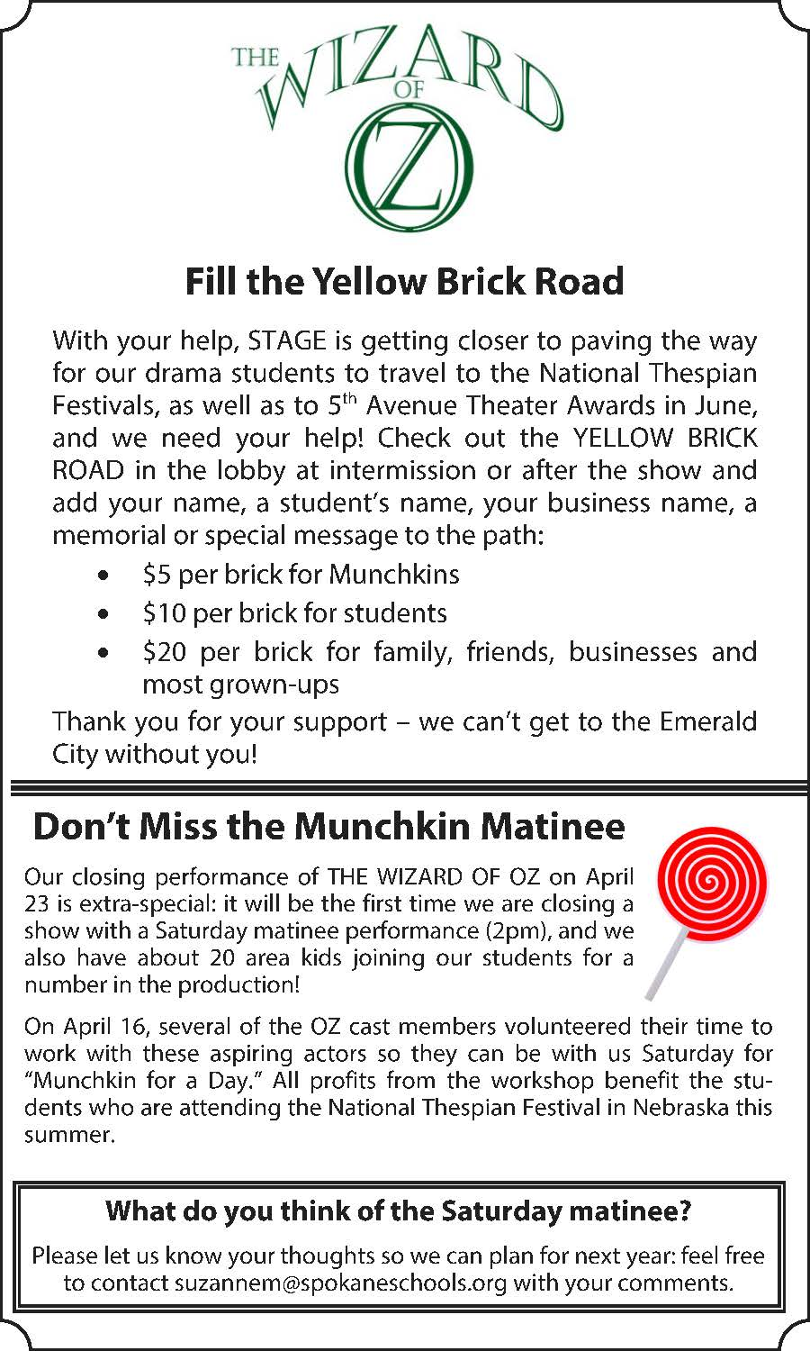
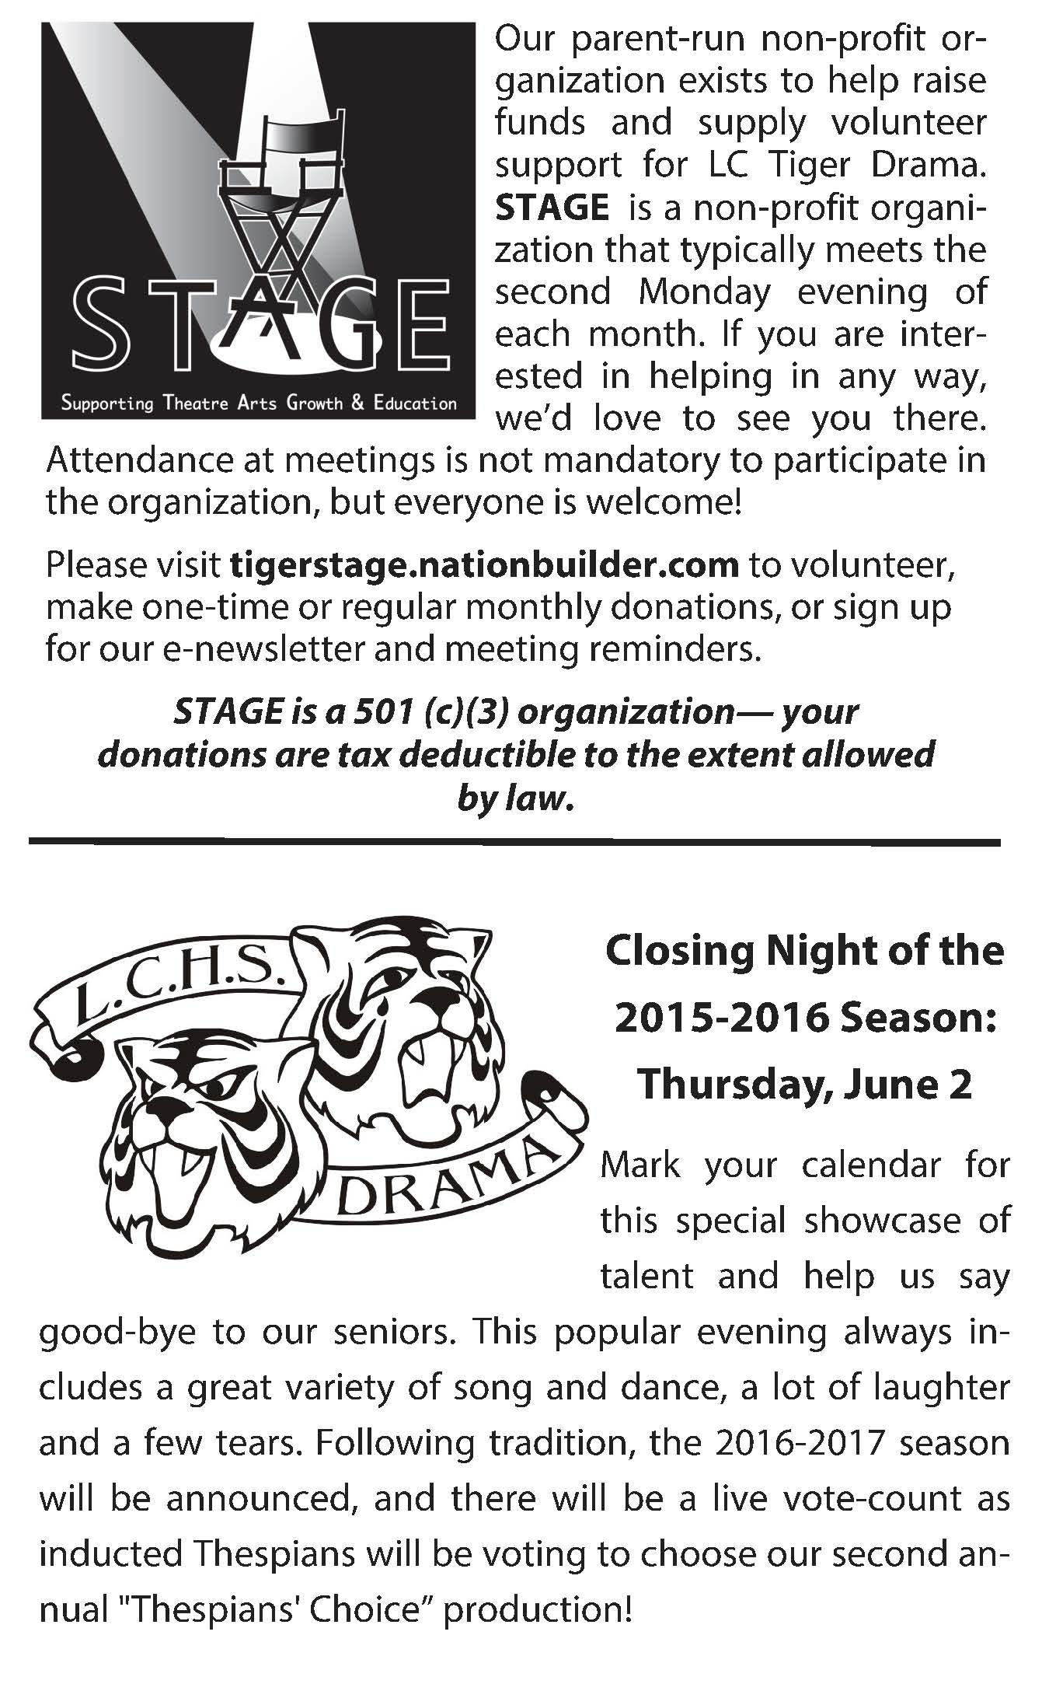
LEWIS & CLARK

TIGER DRAMA
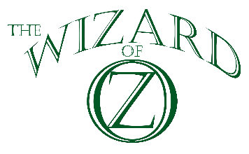
By L. Frank Baum
Music and Lyrics by Harold Arlen and E. Y. Harburg
Background Music by Herbert Stothart
Dance and Vocal Arrangements by Peter Howard
Orchestration by Larry Wilcox
Adapted by John Kane for the Royal Shakespeare Company
Based upon the Classic Motion Picture owned by Turner Entertainment Co. and distributed in all media by Warner Bros.

Greg Pschirrer - Director & Choreographer
Suzanne Maguire - Production Coordinator

Chloe Forsberg | CaraLee Howe | Ilan Hernandez | Ethan Goins
Eric Rorholm | Julian Lee | Beth Lambert | Caleb McKen

with

Micaela Ackermann | Miranda Anthony-Miller | Brianna Barrick
Erin Chaves | Olivia Davis | Tailer Englehart-Grotte
Bailey Heppler | James Hogstad | Vanessa Kaufman
Patrick Lynch | Brittany Mendoza-Pena | Will Petro
 | Claire Woodard

Videographers | Poster Design | Costumers
Richard Maguire | Ruby @ioCreative.com | Lisa Caryl Vukas,  Pauletta Caryl
Program Design | Scene Construction | Scenic Design
Theresa Meyer | Stagecraft Class | Eric Rorholm
Dance Captain & Additional Choreography | Wig Design and Construction | Tinman Costume and Oz Puppet Design
Brittany Mendoza-Pena | Harley Haberman | Bailey Heppler

Adaptation and support materials for the Young Performers’ Edition developed by iTheatrics. Under the supervision of Timothy Allen McDonald
Ilan!  With one look, you can play any part. But that face; that voice are only the start. You don't need to see the Wizard; you already have a brain...and courage, and a tremendous heart. | 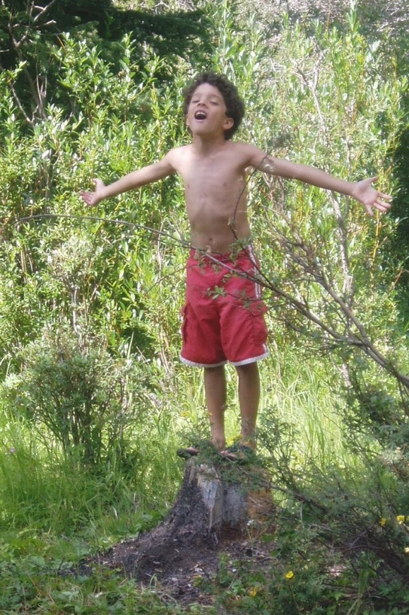
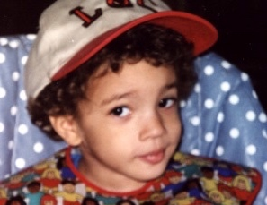  Love you so much!  Emerald City Tía  &  Grandma the Good |  | So down the Yellow Brick Road may you roam - but for fun - without stress, for you know the way home!

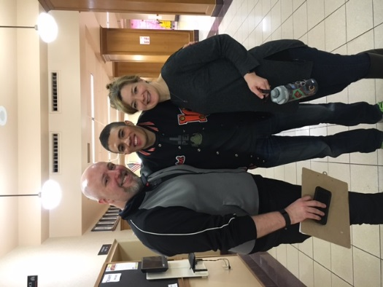
Mr. Pschirrer &
Mrs. Maguire:

Thank you for all the ways that you’ve invested in my life!

You have truly given me a HOME in LC Tiger Drama & on the stage!

With love and admiration,
Ilan

ILan,

You’re off to
new
adventures…

We are so
proud of you!

All Our Love,
Your Montana
Fans,
Grandpa & Grandma
TIGER ROARS

Julian - We love you and have thoroughly enjoyed watching you on stage these past 4 years. What a blessing to see you use the gifts that God has given you. Rock on Wicked Witch!
Dad, Mom and Lucy
Megan - We are so proud of your hard work and dedication to the Drama department. Enjoy your last High School show! We love you!! Mom and Dad |  | To the Senior Class - Break a leg and enjoy every minute of your last High School Show!  The Rosenau Family
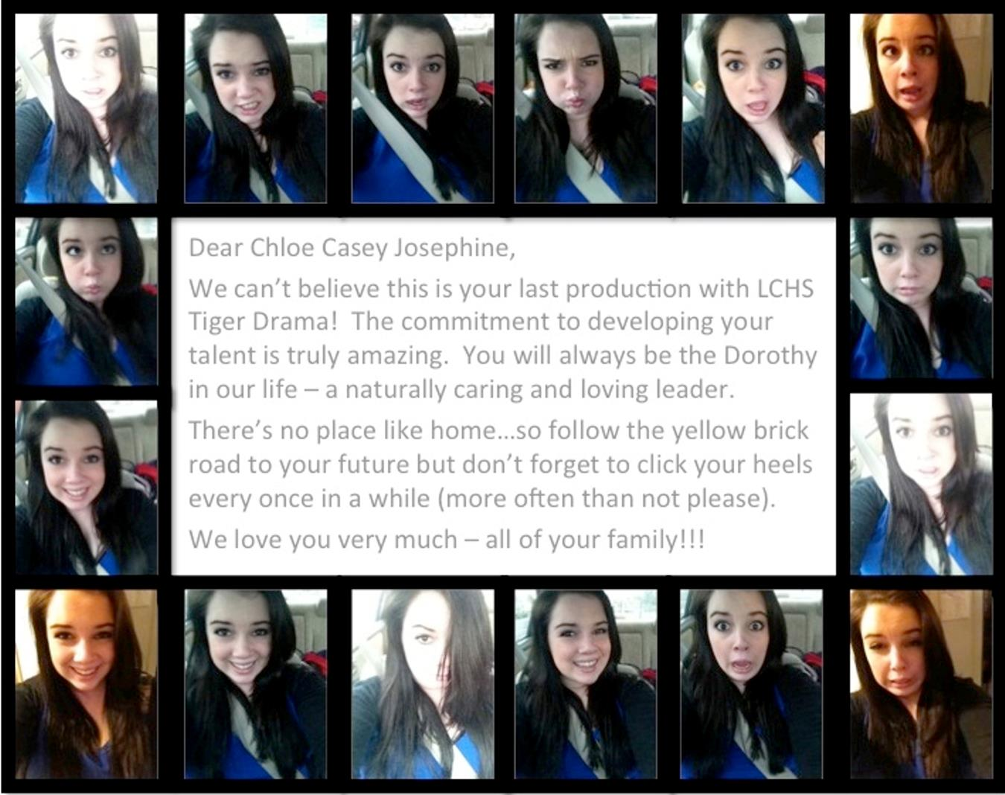
Dear Chloe Casey Josephine,

We can’t believe this is your last production with LCHS Tiger Drama! The commitment to developing your talent is truly amazing. You will always be the Dorothy in our life – a naturally caring and loving leader.

There’s no place like home…so follow the yellow brick road to your future but don’t forget to click your heels every once in a while (more often than not please).

We love you very much – all of your family!!!

WHAT A JOURNEY!

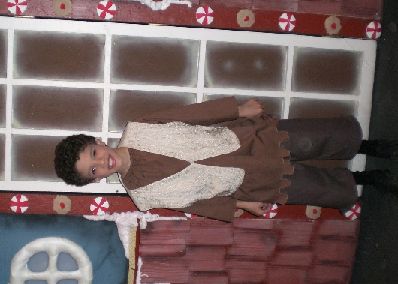
From your 3rd grade stage debut as Frederick in Hansel & Gretel…

To your senior year lead role at LC as Finch in How to Succeed...

You have found your home on the stage! Thank you for giving us so much joy watching you bring so many characters to life.
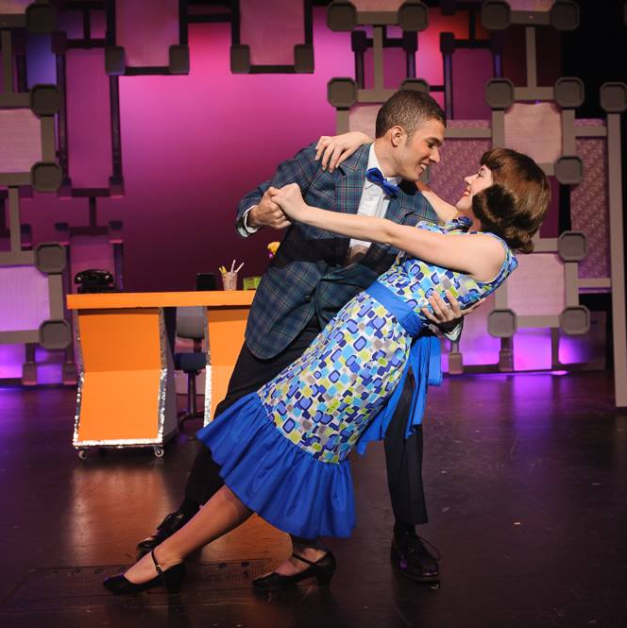
Ilan -- May God guide your steps as you continue your journey.
We Love You!
Dad, Mom, Isaiah
2015 - 2016 SEASON

PAVING THE WAY

This year’s season theme is all about laying the groundwork for future success for students and our department. With production concepts new to Tiger Drama like student directed shows as well as a new Thespian Board format for our student leaders, we are paving the way for Tiger Drama to expand opportunities and continue the tradition of excellence our audiences and school community have come to expect. Please join us and our parent group, STAGE in Supporting Theatre Arts Growth and Education! Thank you for being part of paving the way.

Become a Tiger Drama Patron

If you have the means and the heart to share, please consider being a financial sponsor of LC Tiger Drama.

Examples of what donations will sponsor:
- $50 helps sponsor guest teachers who are experts in their fields (stage make-up, stage combat, lighting design, etc.).
- $100 helps us add scripts to the theatre library, a valuable classroom resource.
- $250 helps us maintain or replace our stagecraft supplies (tools, appliances, lumber, etc.)
- $500 helps us maintain or replace lighting equipment.
- $1,000 helps us pay for the rights for a play.
- $2,500 helps us pay for the rights, scripts, and music for a musical.
- $5,000 helps us maintain or replace parts of our flies system (curtains, rigging, etc.).

Interested in participating or becoming part of STAGE? Want to learn more before committing?
Contact Greg Pschirrer at gregp@spokaneschools.org
MUNCHKIN FOR A DAY

On Saturday, April 16 more than 20 elementary school students joined Tiger Drama students for a workshop, tour of the theater facilities and a chance to learn and rehearse a section of The Wizard of Oz! These munchkins will perform at our closing matinee on Saturday, April 23. “Munchkin for a Day” is a fund raiser for our students attending the International Thespian Festival in Lincoln, NE in June. Following the success of “Who for a Day” two years ago, we wanted to offer another opportunity for older and younger students to collaborate and share their love of theatre! We hope to continue the tradition in the future. Thank you to all who support Tiger Drama and its future!
Munchkins
Abigail Rauth | Adara Crook-Caryl
Addison Wolff | Avi West
Tierney Hart | Taylee Phelps
Sophia Moser | Myles Carpenter
Morgan Cavanagh | Mitchell Crowley
Madilyn Crowley | Maille Hart
Kaitlin Re | Lexi Cheers
Kadynce Scott | Kailee Scott
Jack Salvaggio | Jarin Saggau
Clara Hook | Elizabeth Hollingsworth
Chloe Erin Miciak | Clara Hansen
Brooklyn Barrick
Munchkin Mentors
Lydia Fout | Adonis Fernandes
Noel Case | Sarah Gores
Arianna Meredith | Peris Ochsner
Daria Baer | Dallas Winchester

WHO’S WHO IN THE CAST

Megan Rosenau (Class of 2016) appeared in LC’s How to Succeed… (Hedy LaRue), Midsummer (Titania), and Thoroughly Modern Millie (Ensemble). She thanks Pschirrer and Maguire, her friends and family for their continual support, and her Tiger Drama family for always being there through thick and thin.
Claire Woodard (Class of 2018) is excited to be a part of LC’s production of The Wizard of Oz. This is her fifth LC production, previously appearing in How to Succeed…, Mathematics of Divorce, Into the Woods, and The Trumpet of the Swan. She thanks her friends in the Drama department for making theatre worthwhile.
Hurley (Toto – age 4) is making his theatrical debut in this production. He has thoroughly enjoyed all of the attention he has received from both staff and students. When not acting, Hurley enjoys being snuggled with his humans and biting the cats ankles.

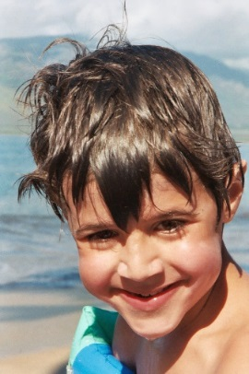
O-Ee-Yah! Eoh-Ah!

We sure love ya!

Kirsten & Mom
Student Design and
Construction
Our CTE Stagecraft students designed and constructed many elements of this production.
- Eric Rorholm* did the Scenic Design for this production and was honored for his work by the State Thespian Festival.
- Harley Haberman designed and constructed the wigs for Glinda, Cowardly Lion, Wicked Witch of the West and Miss Gulch. He also designed and sculpted Glinda’s tiara and staff and the witch’s broomstick.
- Bailey Heppler designed and constructed the costume for the Tinman and the Wizard of Oz head.
- Isabella Weiand* designed and constructed Glinda’s dress and won the Best Costume Construction Category at this year’s State Thespian Festival.
- CaraLee Howe* designed and constructed the Doorkeeper’s costume and won for Best Costume Design at this year’s State Thespian Festival.
*Qualified for the National Thespian Festival
with their design work for The Wizard of Oz

Each of these students worked together with our Stagecraft Class to create our unifying concept design statement to help unify our designs and the production as a whole.
DESIGN STATEMENT:
The Wizard of Oz highlights the overly romanticized imagination of Dorothy as a representation of the hopes, desires, and fears of the common man in stark contrast to the ‘colorless’ bland world of exhausting labour and financial hardship and chasing the lost idea of home through the whirlwind of chaos consuming the 1930s. Dorothy wraps back in time to a vivacious era of fun and joy as she chases the idea of ‘home’ to a visual focal point, hopeful to find peace and joy in the eye of the storm.

CREW

Director/Choreographer……….……………………………….………..Greg Pschirrer
Production Coordinator……………………………………………..Suzanne Maguire
Dance Captain/Additional Choreography……..Brittany Mendoza-Pena
Musical Director……………………………………...…………….………..CaraLee Howe
Scenic Design………….........................................................................................Eric Rorholm
Wig Design/Construction/Styling..............................................Harley Haberman
Tinman & Oz Puppet Design/Construction..............................Bailey Heppler
Glinda Costume Design/Construction………….......................IsabellaWeiand
Doorkeeper Costume Design Construction…………................CaraLee Howe
Costume Supervision & Construction………….......................Lisa Caryl-Vukas
……………………………………………………………............................................Pauletta Caryl
Monkey & Crow Puppet Design/Construction.......................Tina Miller
Lights………….................................................................................................Madeleine Feola*
…………..............................................................................Bethany Daniel, Jackson Bewick
Props………….................................................................................Sue Reiger*, Eli Svoboda
Hair/Makeup.............................................Hannah Summers*, Harley Haberman
…………............................................................................Madison Leeds, Maddy Murphy
Backstage/Flies........................................................Jordan Edwards*, John Jacobson
Costumes......................................................................................................Halaina Halstead*
.........................................................................................................Bri Gardiner, Emelie Silven
Munchkin for a Day Leaders..............................................Sarah Gores, Noel Case
...........................................................................................Adonis Fernandes, Peris Ochsner
...................................................................................................Daria Baer, Dallas Winchester
.................................................................................................Lydia Fout, Arianna Meredith
*indicates crew lead
WHO’S WHO IN THE CAST

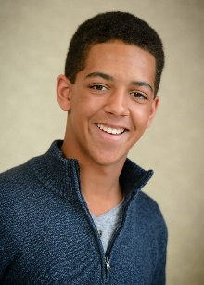 | Caleb McKen (Class of 2018) is excited to be in his 2nd LC show. He has also worked with Civic Theatre, Interplayers, and Spokane Children's Theatre. He plays in LC's Jazz I and loves playing and writing music. He thanks all of his friends and family for their constant love and support.
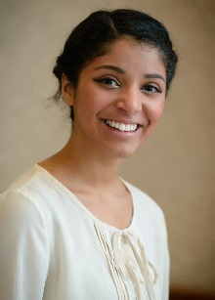 | Brittany K. Mendoza-Peña (Class of 2016) is excited to be a part of her last Tiger Drama production! Previous LC productions include: In the Heights, Thoroughly Modern Millie and Into the Woods. She would like to thank her classmates and mentors for making these past four years such a wonderful journey.
 | Will Petro (Class of 2016) is happy to be performing in his tenth and last show at LC. Previous appearances include: How to Succeed…, Into The Woods, and Seussical. In his spare time, he enjoys creating music with his friends, making art, and learning languages.
 | Eric Rorholm (Class of 2017) is fulfilling a childhood dream of being in Oz. Previous LC shows: How to Succeed and Into the Woods. He is a track athlete and aspiring scenic designer/stage manager. He thanks his friends and theatrical family for giving him the "courage" to succeed, and his track coaches for allowing him to miss so much of the season.
WHO’S WHO IN THE CAST

Vanessa Kaufman (Class of 2018) is excited to be in her first LC production. She previously ushered for Into the Woods and worked on props for How to Succeed… She enjoys musical theatre class and is super excited to finally hit the stage.
Beth Lambert (Class of 2016) is excited to appear in her last Tiger Drama production! Previous LC shows: Thoroughly Modern Millie, Into the Woods, Kelly the Destroyer, How to Succeed, and Civic's White Christmas. She would like to thank past and present Tiger Drama families for making these last four years unforgettable.
Julian Lee (Class of 2016) LC productions include: How to Succeed, Midsummer, & Noises Off. She is grateful to have been a part of this department & thanks Maguire & Pschirrer for helping her grow as an artist & a person, & her family and friends for tirelessly putting up with her dramatic antics all of these years.
Patrick Lynch (Class of 2017) appeared in How to Succeed…and plays in the LC band. He crewed LC’s Midsummer, Trumpet of the Swan, and Into the Woods and is grateful for the opportunity to be in such a wonderful production. He dedicates his performance to everyone in the Drama department for being so supportive.
ABOUT THE DIRECTORS

Greg Pschirrer (Director/Choreographer) is enjoying his 12th season as Drama Director where he has helmed over 35 productions. As a performer, he appeared in: The 25th Annual Putnam County Spelling Bee, Forever Plaid, Cats, and West Side Story. He holds a BA in History (Gonzaga) and an MA in Theatre Production (CWU). This production is dedicated to his parents for instilling a love of storytelling and all the love, support, and guidance over the years.
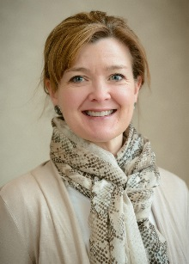
Suzanne Maguire (Production Coordinator) holds a Bachelor’s degree and Secondary Ed. Certification in Speech Communication and Theatre from Northern Arizona University. This is her fifth year happily working with Tiger Drama. For another season of support and participation, she is ever grateful for her wonderful husband, Richard and kids (Brennen, Anna & Elliott)!

STAGE MANAGER

Emma Lyons (Class of 2016) is thrilled to be stage managing her favorite show! Emma has worked on every show during her time at LC, and couldn’t think of a better way to finish. She will be attending the University of Northern Colorado to study Theatre design and technology in the fall. She’d like to thank Pschirrer and Maguire for helping her find her HOME in Tiger Drama.

WHO’S WHO IN THE CREW

 | Daria Baer (Class of 2019) appeared as Alex in The Mathematics of Divorce. She has performed in many Civic Theatre plays, and played Flute and Pyramis in a backyard performance of A Midsummer Night’s Dream. Later in life, she hopes to publish many of her poems, and stories.
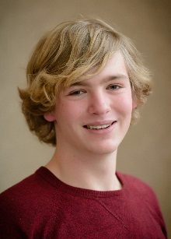 | Jackson Bewick (Class of 2018) is excited to work on his third show for LC Tiger Drama. This will be his third time working on lights, past shows include Into the Woods, and How to Succeed…. He would like to thank Pschirrer and Maguire for this opportunity.
 | Bethany Daniel (Class of 2018) is ecstatic to be gaining some lighting experience in this production! She appeared in LC’s Thespian's Choice and How to Succeed…. Even though she loves being on the stage, she is extremely excited to help out behind the scenes.
 | Madeleine Feola (Class of 2018) plays violin in the LC Chamber Orchestra and won first place in LC’s poetry slam last year. She enjoys painting and hiking in her spare time. This is her third show with LC, after working on crew for Opening Night and Thespian’s Choice.

WHO’S WHO IN THE CAST

Bailey Heppler (Class of 2017) is excited to be working on Wizard of Oz both onstage and off. Most recently she has been seen in How to Succeed (Smitty), Kelly the Destroyer (Indigo), and Midsummer (Puck). She thanks Pschirrer and Maguire for all of the amazing opportunities they give to this department.
Ilan Hernandez (Class of 2016) thanks Pschirrer and Maguire for the opportunities and is excited for this last experience with his senior class as they end their memorable run full of fun and camaraderie. He thanks his family and all his past Tiger Drama brothers and sisters.
James Hogstad (Class of 2016) is excited to be a part of The Wizard of Oz! Previous LC credits include Midsummer (Theseus) and Thoroughly Modern Millie (Kenneth/Ensemble). He thanks Pschirrer and Maguire for everything they have done for him and is grateful to have had a wonderful experience in Tiger Drama.
CaraLee Howe (Class of 2016) is beyond thrilled to play Dorothy. The Wizard of Oz inspired her to follow her dreams wherever they may lead. Next year she will be attending the University of Washington to study medicine and musical theatre. She thanks her mom and dad with all of her heart for fostering her love of the arts.
WHO’S WHO IN THE CAST

Olivia Davis (Class of 2016) has been seen in How to Succeed…, Kelly the Destroyer, Opening Night, and Closing Night. Olivia plans to continue theater in college and pursue a career in law. She thanks her family and friends for the endless support they have given her and dedicates this performance to them.
Tailer Englehart-Grotte (Class of 2016) is excited to perform her last show at LC before becoming a Central Washington University Wildcat! Other Credits include: Bye Bye Birdie, Bring it On (in August), and How to Succeed… “Let’s make this last show great Tigers!”
Chloe Forsberg (Class of 2016) stage managed How to Succeed… and directed The Diary of Adam and Eve. She thanks Pschirrer and Maguire for providing her with so many opportunities, and for being great teachers and mentors. She thanks her parents for giving her rides, even though she is seventeen and should have her license.
Ethan Goins (Class of 2018) is excited to be a part of his fifth LC tiger drama production. He is so happy that this department has welcomed him in with open arms, and is looking forward to his future here. Ethan would like to thank Pschirrer and Maguire and his parents for being so supportive of his interests.

WHO’S WHO IN THE CREW

 | Bri Gardiner (Class of 2019) is excited to be crewing her 2nd Tiger Drama production. After being on crew for How to Succeed…, she fell in love with the LC Drama family and productions. Being a part of LC Tiger Drama has been a major goal of hers and she thanks the rest of the people involved for their hard work.
 | Sarah Gores (Class of 2018) is excited to be a part of her first LC production! She is currently enrolled in Drama 1 and hopes to get involved in future LC shows.
 | Harley Haberman (Class of 2016) is a freelance makeup artist and is happy to be a part of his 5th LC production after working on Midsummer, Into the Woods, and How to Succeed…. He has been the makeup artist on music videos, short films, photo shoots, and other productions. He thanks his parents for their support.
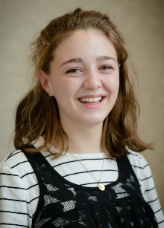 | Halaina Halsted (Class of 2017) is a Running Start Student at Spokane Falls Community College but still participates in the Lewis and Clark Chamber Choir. She has worked on costumes for LC’s Into the Woods and Kelly the Destroyer.., and hopes to help with costumes for many shows to come.

WHO’S WHO IN THE CREW

 | John Jacobson (Class of 2017) is thrilled to be a part of his first LC show! Before moving to Spokane he appeared in Delaware productions of Thoroughly Modern Millie, Into the Woods, and Anything Goes. He thanks Pschirrer and Maguire for giving him this opportunity, and hopes to pursue a career in theatre after college.
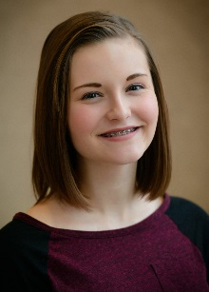 | Maddy Murphy (Class of 2018) participated in LC’s Into the Woods, Meet the Roommates, and How to Succeed…. She is excited to be a part of The Wizard of Oz and have the opportunity of perfecting her hair and makeup skills. Special thanks to Pschirrer and Maguire, as well as Harley for being an amazing mentor.
 | Peris Ochsner (Class of 2018) is excited to participate in her first Tiger Drama production. She’s hoping that this will be one of many in her Tiger Drama career. She usually spends her free time playing soccer or playing softball but loves drama. She would like to thank her parents for letting her be dramatic her whole life.
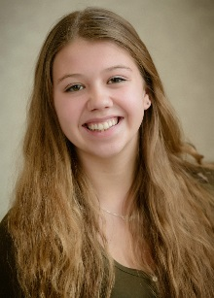 | Emelie Silven (Class of 2016) is a Swedish exchange student. She has been in dance recitals since age three and has even danced in front of the King of Sweden. She’s excited to work on crew for the second time. Emelie would like to thank her host family and parents for giving her the opportunity to be an exchange student.

WHO’S WHO IN THE CAST

Micaela Ackermann (Class of 2018) has previously been seen in LC's How to Succeed… as well as shows at Coeur d'Alene Summer Theatre, Spokane Children's Theatre, Civic, Theatre Arts for Children and Christian Youth Theatre. She dedicates her performance to her family and friends.
Miranda Anthony-Miller (Class of 2018) is excited to be in her first LC production. She loves photography and theatre and worked previously in the department in multiple areas including: costumes, and backstage and Costume crew head for How to Succeed….
Brianna Barrick (Class of 2018) is delighted to be a part of another LC production. She would like to thank Pschirrer and Maguire for all their encouragement this year and her family for their support. She cannot wait to be involved with future Tiger Drama productions.
Erin Chaves (Class of 2018) is excited to be a part of such a fun show with a group of wonderful people! She was last seen on the LC stage in How to Succeed and Thespians' Choice (Eve), and cannot wait for future productions with Tiger Drama! Shout out to all of her friends and family for being so supportive and loving.
SYNOPSIS

Dorothy Gale lives on a Kansas farm with her aunt and uncle. She keeps getting in the way while the adults work, so she finds a quiet place where she won’t get into any trouble - Over the Rainbow. The girl is upset when the mean Miss Gulch comes to take her dog Toto away. However, Toto escapes and joins Dorothy as she runs away from the farm. They meet the kind Professor Marvel, who convinces Dorothy to go back home. When a cyclone hits, Dorothy and Toto seek shelter in her room, where Dorothy is accidentally hit on the head.

When she wakes up, her house has been carried to The Land of Oz, where it lands on and fatally strikes the Wicked Witch of the East, freeing the Munchkins from the Witch’s power - Ding Dong! The Witch Is Dead. The Wicked Witch of the West comes to avenge her sister’s death and to claim her sister’s magic ruby slippers, only to find them on Dorothy’s feet, where the Witch can’t get to them. Dorothy wants to go back home to Kansas, but the Munchkins tell her she must seek help from the Wizard of Oz. So Dorothy is off to see the Wizard - Follow the Yellow Brick Road.

Along the way she meets three new friends and travel companions. The Scarecrow explains why he needs to see the Wizard in If I Only Had a Brain. The Tinman joins them because his life would be better If I Only Had a Heart and the Lion comes along - If I Only Had the Nerve.

Then they arrive at the Merry Old Land of Oz, but the Wizard refuses at first to meet them. The Wicked Witch threatens them again, and they are finally brought to see the Wizard, who will help them only if they prove themselves worthy by bringing him the Witch’s broomstick. So off the foursome goes, through a haunted forest to the land of the Winkies, who guard the Wicked Witch’s castle.

In the forest some winged monkeys capture Dorothy and Toto and take them to the castle, where the Wicked Witch again fails to get the ruby slippers off Dorothy’s feet and threatens to drown Toto. But Toto escapes, just as the Lion, Scarecrow and Tinman come to rescue Dorothy. The Wicked Witch becomes even meaner and threatens the Scarecrow with fire on her broomstick. Dorothy throws a bucket of water at the fire and ends up dousing the Wicked Witch, who screams and melts into nothing. -Ding Dong! The Witch Is Dead. The foursome take the broomstick back to the Wizard, who is revealed as just an ordinary man hiding behind a curtain.

At a graduation ceremony, the Wizard makes the Scarecrow a Doctor of Thinkology, the Lion a member of the Legion of Courage and gives the Tinman a heart-shaped watch. He offers to take Dorothy back to Kansas in his hot-air balloon, but the balloon accidentally takes off without Dorothy and Toto. The good witch Glinda explains to Dorothy how to get home: All she has to do is close her eyes, tap her heels together three times and repeat “there’s no place like home.”

Back in Kansas the storm is over. Dorothy wakes up confused, but soon realizes that there really is “no place like home.”
WHO’S WHO IN THE CREW

 | Hannah Summers (Class of 2018) is excited to expand her theater knowledge. Previous LC shows include Midsummer, Thespians Choice, and How to Succeed… Hannah loves being involved in the drama department and plans to continue throughout her high school career. She would like to thank her mom for all of her love and support.
 | Eli Svoboda (Class of 2019) has been in one LC production, and several studio theater and main stage shows at Spokane Civic Theatre. This will be his first time working backstage. He would like to thank both his father and sister for supporting his endeavors.
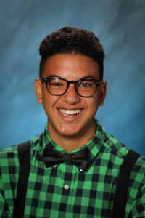 | Dallas Winchester (Class of 2019) is very excited to in his first LC production. He performs well in class so that will help him in the long run. He likes to watch performances and movies as much as being in them. Family is always first to him and that is who he is dedicating this performance to: family.
SPECIAL THANKS
Seth Murphy, ioCreative.com
Diane Ackerman
Tom Bowers
Leah Croteau - LC Bookroom
LC Administration
John Hagney, Carolyn Petek, and Michelle Grafos

Costume Construction Helpers:
Alayna Caryl, Cassie Coleman-Heppler,
Melora Sharts, and Pam Pschirrer
SONG LIST

ACT I
Over the Rainbow……………………………………………………………………..Dorothy
The Cyclone………………………………………………..…………Dorothy & Ensemble
Munchkinland………………...……………………Glinda, Dorothy, & Munchkins
Ding Dong the Witch is Dead………………………………….……………Munchkins
Follow the Yellow Brick Road………………………………………………Munchkins
If I Only Had a Brain………………….……………Scarecrow, Dorothy, & Crows
We're Off to See the Wizard Duet……………Scarecrow, Dorothy, & Crows
If I Only Had a Heart……………………………………Tin Man, Dorothy, & Trees
We're Off to See the Wizard Trio……...……Tinman, Scarecrow, & Dorothy
Lions, Tigers, and Bears………………...………Tinman, Scarecrow, & Dorothy
If I Only Had the Nerve…………..……Lion, Tinman, Scarecrow, & Dorothy
*There will be one 15 minute intermission*
ACT II
Optimistic Voices……...…………………………………………………Ensemble Ladies
The Merry Old Land of Oz……………………………...………………………Ensemble
If I Were King of the Forest…………....Lion, Tinman, Scarecrow, & Dorothy
Over the Rainbow (Reprise)……………...……………………Aunt Em & Dorothy
Winkie March (Reprise)…………………………………………...………………Winkies
Ding Dong! The Witch is Dead……………………………..……………………Winkies
Finale…………………………………………………………………………...……………Dorothy
Bows………………………………………………...……………………...………………Ensemble
CAST

Dorothy……………………………………….………..CaraLee Howe/Chloe Forsberg
Scarecrow/Hickory…………………………...………………….………..Ilan Hernandez
Tin Man/Hunk……………………………………………..…………….………..Ethan Goins
Lion/Zeke…………………………………………………………..…….………..Eric Rorholm
Glinda……………………………………………………..……………….………..Beth Lambert
Marvel/Lollypop Guild/Wizard of Oz……………………..………..Caleb McKen
Aunt Em/City Father/Ozian…………………….………..Tailer Englehart-Grotte
Uncle Henry/Doorman/ Munchkin Mayor…………………………..Will Petro
Miss Gulch/Wicked Witch…………………………………………….………..Julian Lee
Lullabye/Tree/Ozian/Nikko………………...….………..Brittany Mendoza-Pena
City Father/Tree/Ozian/Winkie…...……………...…………….………..Olivia Davis
Barrister/Crow/Ozian/Monkey……………………...………….………..Erin Chaves
Coroner/Crow/Ozian/Winkie……………….…………….………..Claire Woodard
Lollypop Guild/Crow/Ozian/Winkie…………..……….…….…….Patrick Lynch
Lollypop Guild/Crow/Guard/Winkie Leader……….………………………………..
& Scarecrow Standby……………………………………………..……….James Hogstad
Lullabye/Ozian/Winkie……………………….………….………..Vanessa Kauffman
Lullabye/Ozian/Monkey………………...…………….………..Micaela Ackermann
Munchkin/Tree/Ozain/Winkie………………..…………..………..Megan Rosenau
Munchkin/Crow/Ozian/Winkie………………...………….………..Bailey Heppler
Munchkin/Crow/Ozian/Winkie………………..……….………..Brianna Barrick
Munchkin/Ozian……………..….……….………..CaraLee Howe/Chloe Forsberg
Munchkin/Ozian/Monkey………………....….………..Miranda Anthony-Miller

