LEWIS & CLARK TIGER DRAMA

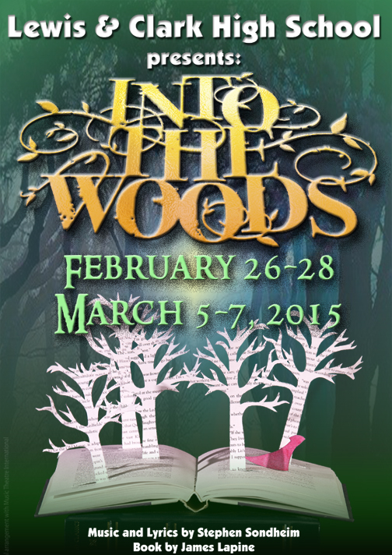

WWW.TIGERDRAMA.COM
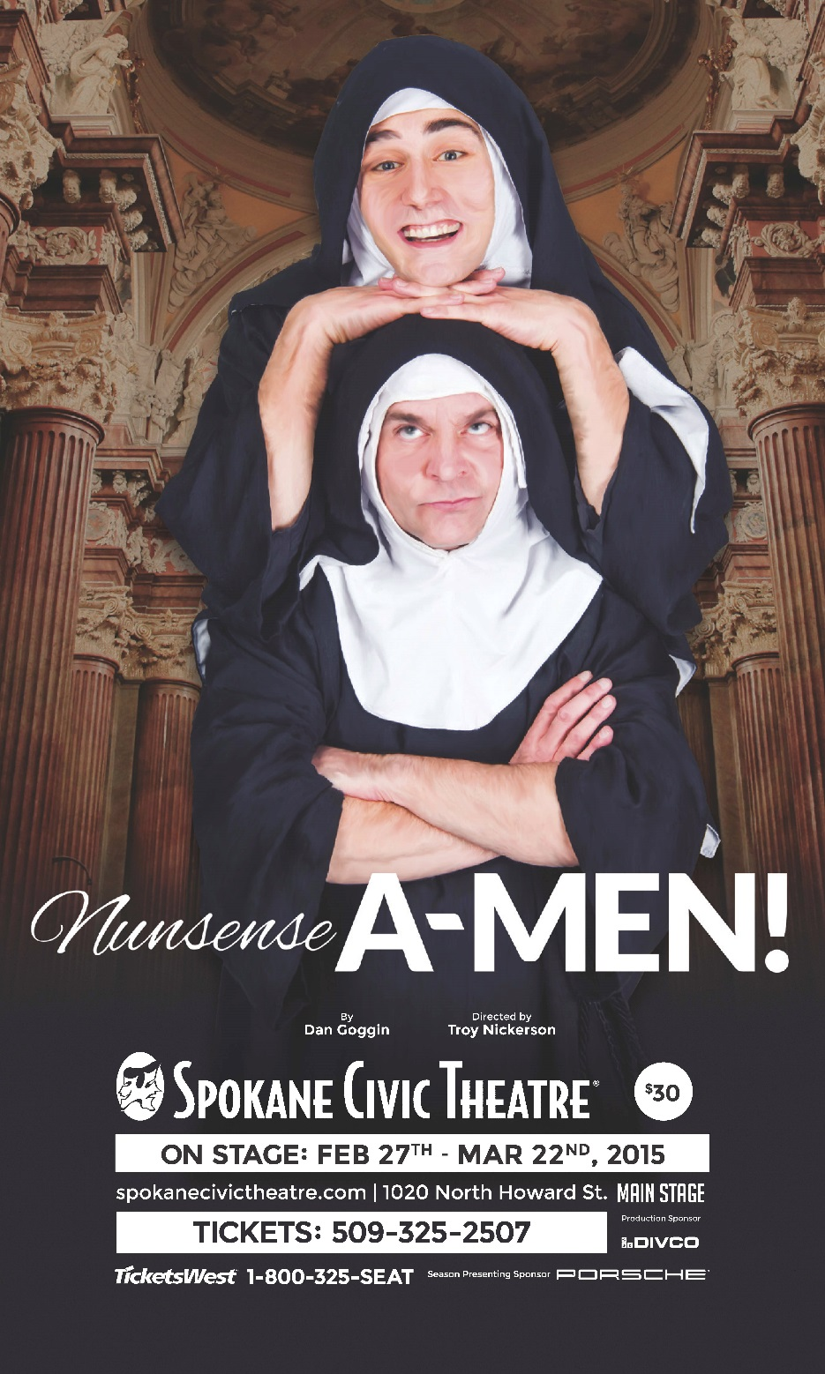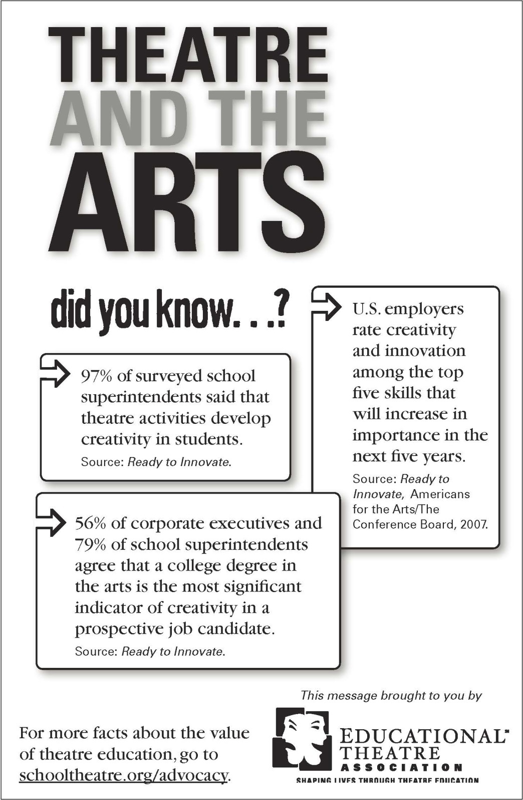
REVISIT OUR PAST SEASONS AT www.tigerdrama.com

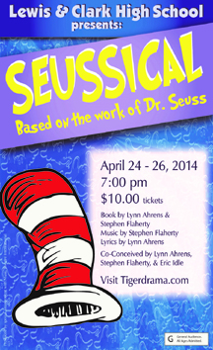 | 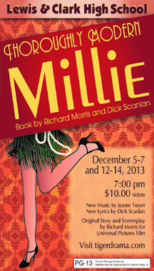 |  | 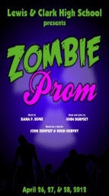
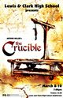 | 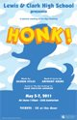 | 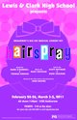 | 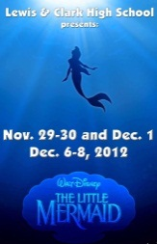
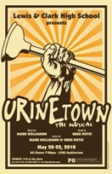 | 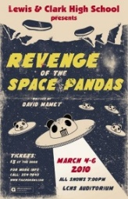 | 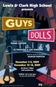 | 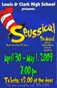
 | 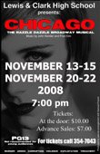 | 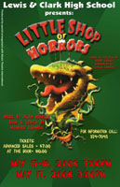 | 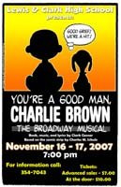

LEWIS & CLARK

TIGER DRAMA

Music and Lyrics by Stephen Sondheim
Book by James Lapine

Greg Pschirrer - Director & Choreographer
Suzanne Maguire - Director & Acting Coach
Caryssa Murphy – Musical Director

Melina Palomba | Bogdan “Theo” Mynka
Brie Cole | Anna Maguire
Ilan Hernandez | Brittany Mendoza-Pena

with

Dominick Betts | Zoe Broadus | Ethan Goins
CaraLee Howe | Beth Lambert | Julian Lee
Anissa Martinez | Will Petro | Kezia Rhodes
Eric Rorholm | Liam Schaaf | Sarah Wier
Kahlil Wilson-Moore |  | Claire Woodard

Lighting Design | Poster Design | Costumer
Emma Lyons | Anna Maguire | Lisa Caryl Vukas
Program Design | Rapunzel Hair Design | Hair Design
Theresa Meyer | Christian Haberman | Jeanette Brenner
Spiral Stair Construction | Scene Design/Construction | Headshots
Braeden Tyler-Babkirk & Dean Tyler-Babkirk | Stagecraft Class | Scott Martinez & Richard Maguire

Produced by special arrangement with Music Theatre International.
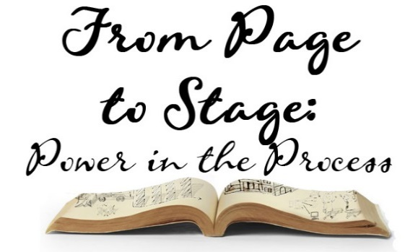
OUR 2014-2015 SEASON
FROM PAGE TO STAGE:
POWER IN THE PROCESS

Our 2014-2015 Tiger Drama Season theme is ‘From Page to Stage: Power in the Process’. From a Shakespeare classic to a brand new 21st century musical, this season demonstrates what students and audiences can learn from the powerful process of bringing words to life and collaborating in the creative development of a production. In November, we collaborated with our AP literature classes to study and present Shakespeare’s A Midsummer Night’s Dream. Along with our symphonic band and orchestra, we were the first high school in the country to bring the E.B. White classic children’s novel The Trumpet of the Swan to life in December. We are exploring how a theme can be presented thematically through subject matter, but also through physical, visual, and scenic elements as well. Having students be part of creating this season has been exhilarating and daunting but a challenge that has forced us all to realize the vast amount of skills and talents necessary to create such complex stories. Time management, collaboration, creative and critical thinking, perseverance and resilience are just a few of the skills taught, practiced and refined in the process of bringing each of the shows this season to life.

Melina,
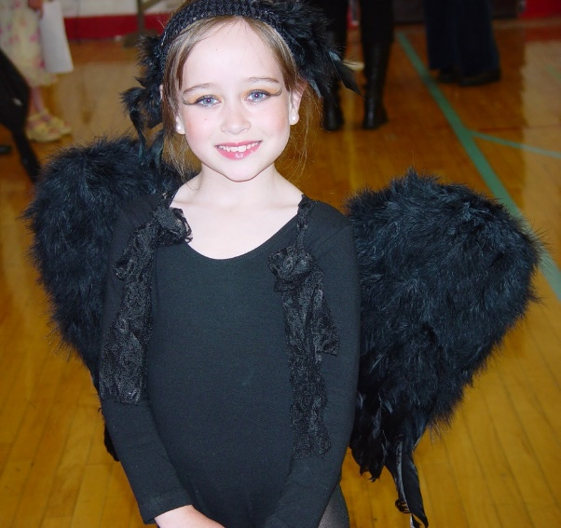
Have a great time with The Witch!

We are so privileged to have watched you transform into an amazing young lady.

Break a leg!
Love, Dad, Mom, & Daniel
Brie,
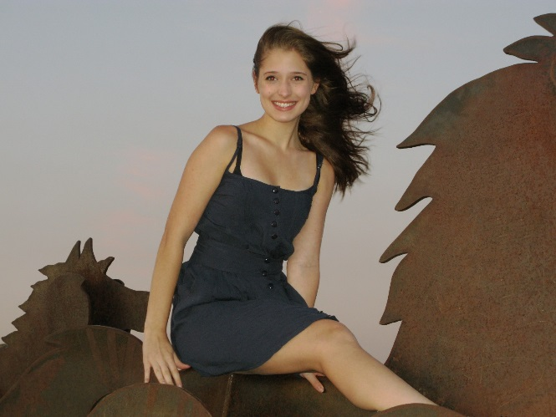
Whether you are riding to the top of a hill, into the woods, or off to become a world-renown thespian, ride hard, with grace and grit...and finish strong!

Love, Dad and Mom
My Dearest Melina,

It has been such a pleasure. I have so enjoyed watching you become the beautiful young lady you are today. No Grandmother could be prouder. I am so looking forward to the show and feel pretty certain I will never see a lovelier "witch". In Boca Lupo, Sweetie!!!

Love you tons, Grandma.
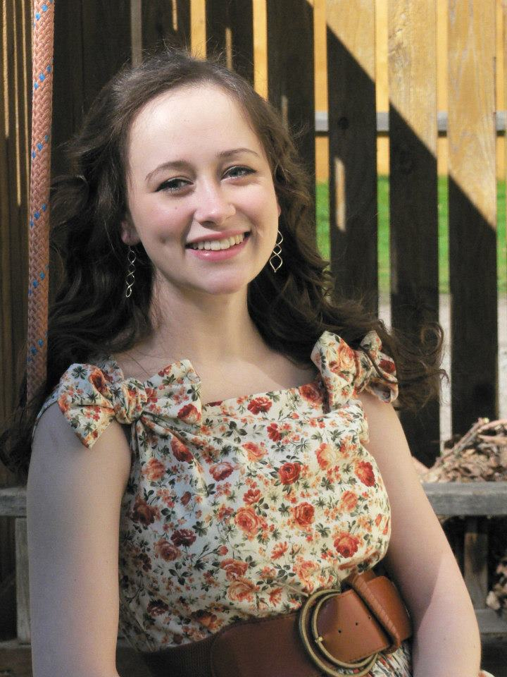
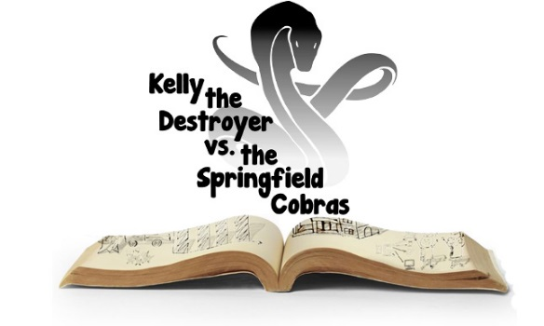
KELLY THE DESTROYR
VS. THE
SPRINGFIELD COBRAS

Perhaps the most exciting aspect of following the process of material going from page to stage is the creation of a 21st century, world premiere musical: Kelly the Destroyer vs. the Springfield Cobras. This production has been created by composers Rob Hartmann and Katie Kring working with students in our Musical Theatre class. Covering 21st century themes of increased standardized testing, academic pressures and student individuality within mounting educational uniformity, Tiger Drama’s production of Kelly may open the door for discussion, dialogue and opportunities for other schools throughout the country to share.

Work on this show began last spring when students auditioned knowing nothing more than the title of the show. Over the summer, Rob and Katie worked to create a structure/framework for the production. This fall, the collaboration began. Students have been involved in forming their own characters, tracing themes in education and offering input on the complex issues they confront as they prepare for life beyond high school.

We hope you will join us April 24 and 25 as we bring this world premiere musical to life!

WHAT YOU SEE ONSTAGE

All of our shows in our Page to Stage season find their roots in literature. We wanted this production to visually represent this literary tie. Many of the scenic elements you see onstage were used in both The Trumpet of the Swan and Midsummer from earlier this season. They have been repurposed and given a new life for this production.

As part of our continued dedication to making our sets from recycled and reused material, we wanted to ensure that once our season is completed, the paper products you see onstage all are recycled, donated, or returned to their original owners. The books that help make up our set are a mixture of our rare and vintage collection from the LCHS library, and books that had been discarded and sent for recycling. We are glad that they can find new life in this production and that the work of literally hundreds of authors are represented onstage.

We also wanted our set and costumes to have elements of the original text from the shows and source materials from this season. The costumes for Into the Woods contain text from the original Brother’s Grimm stories and thematically help display the journey of each character. As they stray farther from their stories, elements of their text begin to disappear or change. These touches can be very subtle, but they have helped shape our design for the entire production. The trees onstage are also adorned with text from all four of the shows featured in this season. We hope that you will enjoy interacting with the text in this production as much as we have!

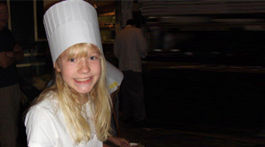
Anna!
We are so proud of all your memorable moments on the LC stage and we are so grateful for who you are. Savor every moment as the Baker's Wife!
We love you - your family
ILAN…We know you can take on any giant! Keep enjoying your theatre adventures! We are so proud of you! Love You, Dad, Mom & Isaiah
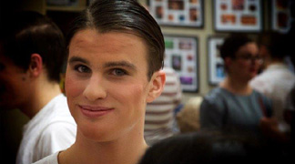
Bogdan (Theo),

So proud of you and your journey Into the Woods!

Break a leg!

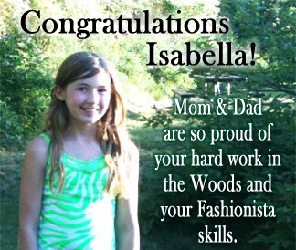
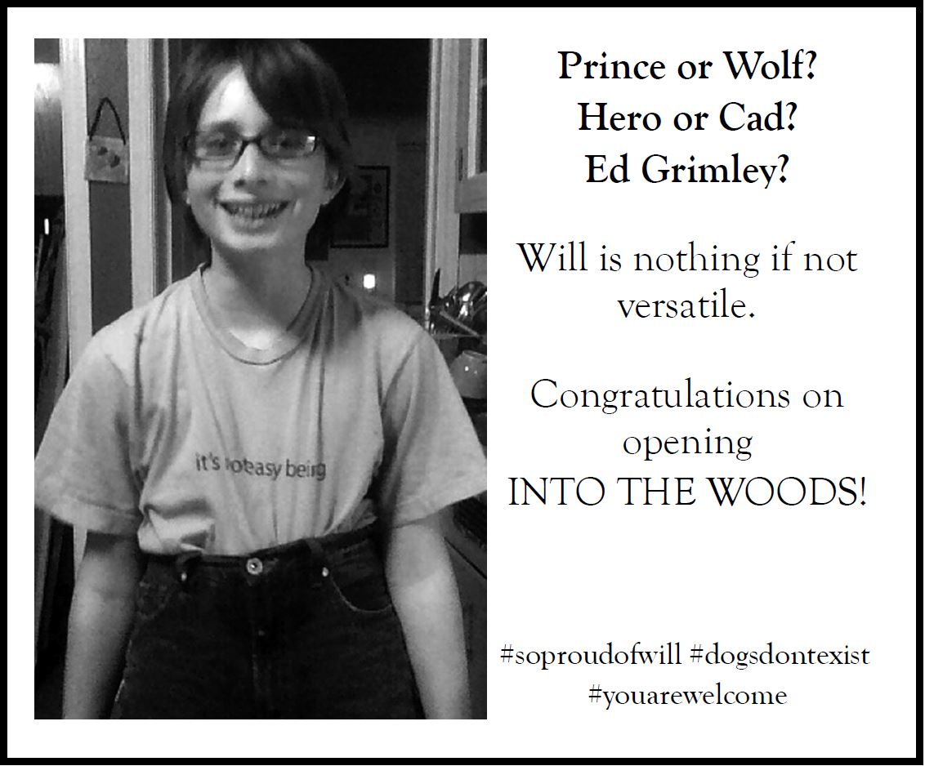

DIRECTORS’ NOTES

Into the Woods has impacted and touched our lives personally and professionally. The profound themes, timeless tales, and incredible score make it a classic musical that continues to see success with every professional revival, high school, and community theater production. The opportunity to tackle what we have fondly labeled a “beast” of a production also gave us a chance to work together and allow the students the experience of working with two directors demonstrating the power in collaboration. We are so thankful for our entire artistic team and all of the parent, staff, and community support that make it possible for us to continue to provide high caliber educational theatre.

It has been a privilege to work with these young artists and watch them bring their own ideas and viewpoints to this material. We are passionate about this show and the profound themes including: relationships between parents and children; what we leave to future generations; conquering the giants of life; the difference between ‘good’ and ‘nice’; and pursuing your happily ever after. That is why we wanted to undertake this classic piece as part of this ambitious season.
ORCHESTRA

Horn 1................................................................................................Bill Schulman
Horn 2.....................................................................................................Paul Manly
Reed 1 (Flute)...................................................................................Leslie Thistle
Reed 2 (Clarinet).....................................................Grant Cook (Class of 2015)
Reed 3 (Bassoon)..............................................Matt Wildman (Class of 2015)
Trumpet...........................................................................................Jesse Flanagan
Percussion.................................................................Jo Lockhart (Class of 2015)
Piano.......................................................................................................Evan Wang
Synth........................................................McKenna Susemiehl (Class of 2017)
Violin 1.....................................................................Cory Cogley (Class of 2015)
Viola 1............................................................Mackenzie Grady (Class of 2015)
Viola 2...........................................................Edward Wardwell (Class of 2017)
Cello..........................................................................Anna Seppa (Class of 2017)
Bass..........................................................................Adriaan Luu (Class of 2015)
Conductor...................................................................................Caryssa Murphy
SPECIAL THANKS

Rex Forsberg | Richard Maguire
Ellicia Elliott | Scott Martinez
Pauletta Caryl | George and Briane Green
Jeanette Brenner | U-High Drama
Braeden & Dean Tyler-Babkirk | Jim Swoboda
Lynda Tschabold | Marianne Dunn
Pam Pschirrer | Brian Ritter
Ben Bentler | Abbey Crawford
Keith Dixon | Marnie Rorholm
Spokane Civic Theatre | Silhouette Lighting
Richland High School Drama | STAGE Parents & Families

2015 TIGER DRAMA DATES
March 19-21 State Thespian Festival - WWU - Bellingham
April 20-23 Dress Rehearsals - Kelly the Destroyer
April 24-25 Kelly the Destroyer vs. the Springfield Cobras
May 11-12 Auditions - Closing Night
June 2-3 Dress Rehearsals - Closing Night
June 4 Closing Night
June 8 5th Ave Awards - Seattle

Stay updated on everything that is going on at LC!

Visit
www.lctigers.com
Become a Tiger
Drama Patron

If you have the means and the heart to share, please consider being a financial sponsor of LC Tiger Drama. Examples of what donations sponsor:

- $50 helps sponsor guest teachers who are experts in their fields (stage make-up, stage combat, lighting design, etc.).
- $100 helps us add scripts to the theatre library, a valuable classroom resource.
- $250 helps us maintain or replace our stagecraft supplies (tools, appliances, lumber, etc.)
- $500 helps us maintain or replace lighting equipment.
- $1,000 helps us pay for the rights for a play.
- $2,500 helps us pay for the rights, scripts, and music for a musical.
- $5,000 helps us maintain or replace parts of our flies system (curtains, rigging, etc.).

Interested in participating or becoming a Tiger Drama Patron?
Email tigerstagegroup@gmail.com
CREW

Hair & Makeup.......................................Anna Budke*, Mayzie Dunlap,
..............................................................Christian Haberman, Cori Gillis,
.................................................................Megan Rosenau, Emma Kraby
Costumes...................................................Kendra Gores*, JJ McDirmid,
............................................................Isabella Weiand, Halaina Halsted
Lights......................................................Jillian Burgess, Katie Grainger,
...............................................................Emma Lyons*, Jackson Bewick,
.........................................................................................Holly Edwards
Sound............................................................James Elkin, Patrick Lynch
Milky White Sculpted Cow Head....................................Bailey Heppler
Props...............................................Audrey Bensching, Tyese Chumov,
.........................................................Bailey Heppler*, Jessica Daugherty
Flies/Backstage............................Isabella Weiand*, Jackson McMurray,
..............................................................Ben Fischer, Caroline Halvorson
House Managing.....................................Katlynn Souers*, Erin Chaves
Ushers.............................................................Mia Hunt, Emily Phillip,
.....................................................Annalisa DeFord, Vanessa Kaufman,
...........................................................Maddy Murphy, KiraJ Cinq-Mars,
...................................................Caroline Egli, Miranda Anthony-Miller
* indicates crew lead
ABOUT THE DIRECTORS

Greg Pschirrer (Director/Choreographer) is enjoying his 12th season as Drama Director where he has helmed over 35 productions. As a performer, he appeared in: The 25th Annual Putnam County Spelling Bee, Forever Plaid, Cats, and West Side Story. He holds a BA in History (Gonzaga) and an MA in Theatre Production (CWU). This production is dedicated to his parents for instilling a love of storytelling and all the love, support, and guidance over the years.
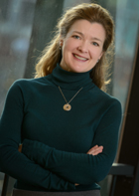
Suzanne Maguire (Director/Acting Coach) holds a Bachelor’s degree and Secondary Education Certification in Speech Communication and Theatre from Northern Arizona University. She is grateful to Mr. Pschirrer for inviting her to work with Tiger Drama. For another season of support and participation, she is ever grateful for her wonderful husband, Richard and kids (Brennen, Anna & Elliott)!
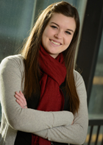
Caryssa Murphy (Musical Director) is excited to once again be partnering with Tiger Drama for a musical. As the choir director at LC, she has most recently conducted Thoroughly Modern Millie and In the Heights, as well as music directed The Little Mermaid Jr and Seussical Jr. She can also be seen around town in various productions through Spokane Civic Theater and the Modern Theater. She would thanks her husband for his continuing support for her love of the arts.

WHO’S WHO IN THE CAST

 | Liam Schaaf (Narrator - Class of 2015) has appeared in LC’s Thoroughly Modern Millie, Noises Off, Seussical, and A Midsummer Night's Dream. He is on the LC Knowledge Bowl team and thanks Pschirrer and Maguire for teaching him everything he knows about theatre, and for allowing him to put that knowledge to use.
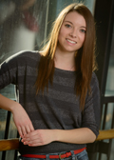 | Sarah Wier (Rapunzel - Class of 2015) is thrilled to be in another LC production! She has previously appeared in The Trumpet of the Swan, Seussical, and Thoroughly Modern Millie, as well as Legally Blonde (Serena) at Civic. Sarah would like to thank her wonderful family and Junior Villaro for their never ending love and support.
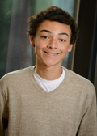 | Kalil Wilson-Moore (Cinderella’s Father - Class of 2016) is a drum major and sax player for the LC Band, as well as a member of the LC debate team. This is his first show and he is very excited to be a part of this production!
 | Claire Woodard (Granny/Giant - Class of 2018) is excited to be in her second Tiger Drama production and first LC musical. She previously appeared in The Trumpet of the Swan and Legally Blonde at the Spokane Civic Theatre Summer Academy.
WHO’S WHO IN THE CAST

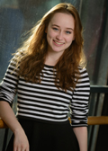 | Melina Palomba (Witch - Class of 2015) is excited to be involved in her eleventh Tiger Drama production. Previous productions include: Thoroughly Modern Millie, Seussical, and The Little Mermaid. She dedicates this performance to her parents, brother, and friends for their constant support and love.
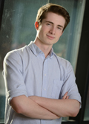 | Will Petro (Wolf/Cinderella’s Prince - Class of 2016) is excited to be in his seventh show at LC. Previous appearances include Seussical and Noises Off. In his free time he enjoys making music and studying languages. "If you live among wolves you have to act like a wolf."
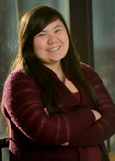 | Kezia Rhodes (Stepmother - Class of 2015) previously appeared in Tiger Drama’s The Trumpet of the Swan and Seussical. She thanks her family for all of their support and her friends for all of the love. "I am Groot." - Groot
 | Eric Rorholm (Steward - Class of 2017) is thrilled to be in his first LC production. He previously worked on crew for Trumpet of the Swan and performed in Gypsy and Fiddler on the Roof at Spokane Civic Theatre. He thanks Pschirrer and Maguire for the opportunity to be part of such a richly beautiful show!
ABOUT THE COSTUMER

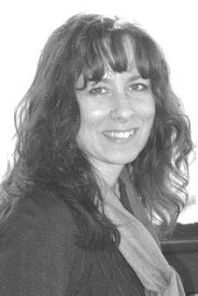 | Lisa Caryl (Costumer) has costumed shows for Spokane Civic Theatre, Interplayers, Spokane Children's Theatre, and Actors Repertory Theatre. She works as a costume designer with North by Northwest Productions. Lisa is thrilled to be working with this amazing program.

ABOUT THE STAGE MANAGERS

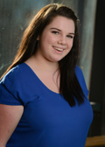 | Chloe Forsberg (Stage Manager - Class of 2016) recently completed LC’s production of A Midsummer Night’s Dream (Hermia) and performed in Opening Night and Closing Night last year. She assistant stage-managed Noises Off, and thanks Pschirrer and Maguire for all of her opportunities! She also thanks her family for their support and driving her where she needs to be!
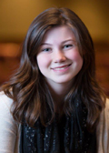 | Hannah Kinsella (Stage Manager - Class of 2017) is excited to be assistant stage-managing Into the Woods. This is her second production at LC and she hopes to continue working with the Lewis and Clark Drama Department into her senior year. She thanks Mr. Pschirrer and Mrs. Maguire for this amazing opportunity.
WHO’S WHO IN THE CREW

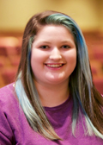 | Miranda Anthony-Miller (Class of 2018) is excited to be on crew for the second time. She enjoys helping backstage and loves the theater. She hopes to continue to participate in theater throughout high school.
 | Jackson Bewick (Class of 2018) is having a great time in drama class this year and is excited to be on crew for this production.
 | Audrey Bensching (Class of 2018) is excited to be helping out with her first LC production. She has been trained in various styles of dance over the last five years at the Dance Center of Spokane. She thanks her friends, family, and Maguire and Pschirrer for allowing her to be part of this wonderful show.
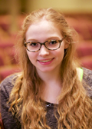 | Jillian Burgess (Class of 2015) is ecstatic to be a part of Into the Woods. She has been on crew for many LC productions including The Little Mermaid, In The Heights, Thoroughly Modern Millie, and Noises Off. She is excited to continue her last year at LC with such an incredible group of kids and hopes to attend WWU in the fall.

WHO’S WHO IN THE CAST

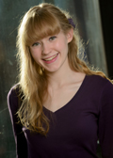 | Anna Maguire (Baker’s Wife - Class of 2015) previously appeared in LC’s The Trumpet of the Swan and Seussical. She dedicates her performance to her mother, who let little Anna steal her CD of this show and listen to it repeatedly all the time.
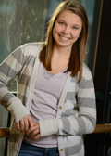 | Anissa Martinez (Milky White/Snow White - Class of 2015) is excited to be in her second LC production after Seussical. She has been on crew for numerous LC shows. In her spare time, she keeps herself busy with ballet and participating on LC's varsity track team in the spring. Anissa is an avid lover of cats.
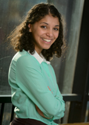 | Brittany Mendoza-Pena (Little Red - Class of 2016) is honored to be a part of this production. Previous LC appearances include Trumpet of the Swan, Thoroughly Modern Millie and In the Heights. She plans to pursue theater as a career and thanks her beloved cast and crew for their hard work and dedication to this production.
 | Bogdan (Theo) Mynka (Baker - Class of 2015) previously appeared in Thoroughly Modern Millie and All Is Calm. He will be attending the All-Northwest Honors Choir and he thanks his directors and his mother, for all the time she invested in him. Most of all, he thanks God, without whom this would never be possible.
WHO’S WHO IN THE CAST

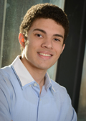 | Ilan Hernandez (Jack - Class of 2016) appeared in LC’s A Midsummer Night’s Dream, In The Heights, The Dining Room, Thoroughly Modern Millie, and The Little Mermaid. He truly values the incredible theatre education he receives at LC and thanks his family for believing in him.
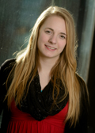 | CaraLee Howe (Jack’s Mother - Class of 2016) previously appeared in LC’s A Midsummer Night's Dream, Thoroughly Modern Millie, and Seussical. She also performs with many local Spokane community theaters, and dances with Dance Arts Academy. Special thanks to Mr. Pschirrer and Mrs. Maguire for this opportunity!
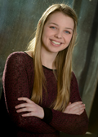 | Beth Lambert (Lucinda - Class of 2016) is honored to be a part of this production! She previously appeared in LC’s production of Thoroughly Modern Mille. She plans to pursue a degree in Musical Theatre and dedicates her performance to her family and friends and thanks them for all of their love and support.
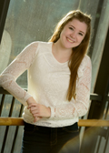 | Julian Lee (Florinda - Class of 2016) previously appeared in LC’s A Midsummer Night's Dream, Noises Off, The Dining Room, and Seussical. She enjoys writing songs and creating films. She thanks Maguire and Pschirrer for all the time they've put into helping her grow as an artist and person. Their support means the world to her.
WHO’S WHO IN THE CREW

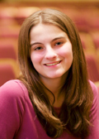 | Erin Chaves (Class of 2018) is super excited to be working on her first LC production! She was in Opening Night earlier this year, as well as SCT's The Little Mermaid. Erin has always enjoyed the arts in general, and looks forward to the coming years ahead with Tiger Drama.
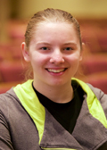 | Tyese Chumov (Class of 2016) previously appeared in LC’s A Midsummer Night's Dream (Prudence Quince) and enjoyed the thrilling experience of the stage life. She thanks her friends for always making things an adventure and her parents for telling her to never miss a valuable opportunity when it's present.
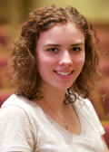 | Jessica Daugherty (Class of 2017) plays Tenor Saxophone in the LC Band. She enjoys reading, writing, being with friends, and snow skiing in her free time. This is her first LC production and she is thankful for the opportunity. Jessica thanks her family and friends for their love and support.
 | Maizie Dunlap (Class of 2017) is excited to be on the crew. Previously, she has worked on the LC production of Noises Off! She loves theatre and she is thankful for this opportunity. Maizie would like to thank her parents and siblings, especially her older brother Sam, for their encouragement and support.
WHO’S WHO IN THE CREW

 | James Elkin (Class of 2015) is beyond excited to be working on the sound design for LC's production of Into the Woods. He has previously appeared in Opening Night, and Trumpet of the Swan, and is ready to journey into the world of technical theatre.
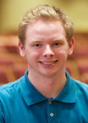 | Benjamin Fischer (Class of 2017) is excited to see “behind the scenes” of a LC production. He previously appeared in Thoroughly Modern Millie, and he enjoys singing and dancing. He thanks his parents for supporting him with whatever he wants throughout his life, and can’t wait to put on a great show.
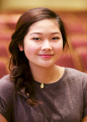 | Cori Gillis (Class of 2017) is excited to be working on her third production at LC! She has been in A Midsummer Night’s Dream (Fairy) and worked crew on Seussical. She thanks Pschirrer and Maguire for the opportunity to be involved in this show.
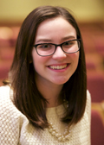 | Kendra Gores (Class of 2015) is excited to be a part of her first production at Lewis and Clark as a member of the Into the Woods crew. She has loved going to sports games as an LC Tiger. She enjoys spending time with family and friends and is so thankful for their love and support throughout her high school career.

WHO’S WHO IN THE CAST

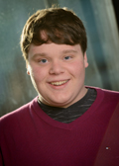 | Dominick Betts (Mysterious Man - Class of 2015) is honored to be in one of his favorite shows. Favorite Roles include Seussical (Horton) at LC and Legally Blonde (Emmett) at Civic. He dedicates his performance to his friends and family that are with him through it all. He hopes to pursue acting and directing in his future.
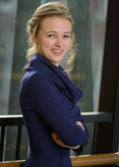 | Zoe Broadus (Cinderella’s Mother/Sleeping Beauty - Class of 2015) was last seen in LC's Seussical (Mrs. Mayor), and is thrilled to be joining this cast. She would like to thank everyone who gave her the extra push to get back into theater, and her family for keeping everything together for her.
 | Brie Cole (Cinderella - Class of 2015) is sad her Tiger Drama journey is coming to an end after appearing in 12 LC productions including The Little Mermaid, In the Heights, Noises Off, and The Crucible among others. She thanks her parents, and every teacher who has helped her become who she is today.
 | Ethan Goins (Rapunzel’s Prince - Class of 2018) is the principle bassist for the Spokane Youth Symphony Philharmonic, is in the LC Chamber Orchestra, Jazz Band 1 and plays in a jazz combo, Cool Talk. He is eager to expand his fine arts experiences and thanks his parents.
CAST
In order of appearance

Narrator................................................................................Liam Schaaf
Cinderella..................................................................................Brie Cole
Jack..................................................................................Ilan Hernandez
Milky White/ Snow White.............................................Anissa Martinez
Baker.......................................................................Bogdan Theo Mynka
Baker’s Wife......................................................................Anna Maguire
Cinderella’s Stepmother....................................................Kezia Rhodes
Florinda....................................................................................Julian Lee
Lucinda..............................................................................Beth Lambert
Cinderella’s Father.................................................Kahlil Wilson-Moore
Jacks’ Mother...................................................................CaraLee Howe
The Witch.......................................................................Melina Palomba
Little Red Riding Hood.....................................Brittany Mendoza-Peña
Cinderella’s Mother/Sleeping Beauty..................................Zoe Broadus
Mysterious Man..............................................................Dominick Betts
Cinderella’s Prince/Wolf..........................................................Will Petro
Rapunzel................................................................................Sarah Wier
Rapunzel’s Prince...............................................................Ethan Goins
Granny/Giant.................................................................Claire Woodard
Steward...............................................................................Eric Rorholm
WHO’S WHO IN THE CREW

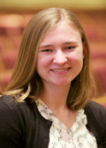 | Katie Grainger (Class of 2016) has crewed for shows such as Thoroughly Modern Millie and Noises Off. She is excited to be a part of another LC production.
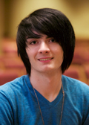 | Christian Haberman (Class of 2016) is honored to be a part of this production after previously crewing A Midsummer Night’s Dream. He enjoys being a makeup artist, working on music videos and photo shoots. He plans on attending Cinema Makeup School in L.A. after high school. He thanks his parents for being his biggest support system.
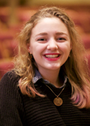 | Halaina Halsted (Class of 2017) is overjoyed to work on the costume crew for her first LC production! She currently sings in SAYC choirs and the women's ensemble here at LC. She also thanks her mom for fostering her love for musicals by taking her to many Civic Theatre productions.
 | Caroline Halvorson (Class of 2016) previously appeared onstage in Thoroughly Modern Millie. She is excited to be working backstage for Into the Woods!
WHO’S WHO IN THE CREW

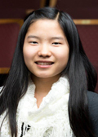 | Mia Hunt (Class of 2016) is delighted to be a part of the LC Drama Program. This is her second crew experience with a LC production. She enjoyed being on hair and makeup crew for LC's production of A Midsummer Night's Dream.
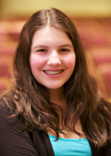 | Vanessa Kaufman (Class of 2018) plays Softball and is part of the LC Advanced Orchestra. She has been in Musical Theatre Dance for 3 years and has taken private lessons for viola for 2 years. She previously appeared in Odd Ball at Sacajawea Middle School. This is her first production at LC and she is very excited.
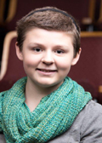 | Emma Lyons (Class of 2016) is tickled to be designing lights! She previously stage managed Trumpet of the Swan, and designed lights for Seussical, Noises Off, and Trumpet of The Swan. She thanks her mom for her dedication to her success, and Greg Pschirrer, for teaching her everything she knows about technical theatre.
 | Justina (JJ) McDirmid (Class of 2018) is excited to be working on this production. She plans on continuing with the drama department, and wishes to work on her photography skills, writing abilities, and art talent. She thanks her family, friends, and most importantly the department for being so supportive and caring.
SONG LIST
Act I
"Act One Prologue: Into the Woods”................................Narrator & Company
“Cinderella at the Grave"...............................Cinderella & Cinderella's Mother
"Hello, Little Girl"................................................Wolf & Little Red Ridinghood
"The Spell is On My House" (Reprise)................................Baker & Baker's Wife
"I Guess This is Goodbye"............................................................................Jack
"Maybe They're Magic".....................................................Baker & Baker's Wife
"Our Little World".................................................................Witch & Rapunzel
"Maybe They're Magic" (Reprise)……………...………………...............Baker
"I Know Things Now"......................................................Little Red Ridinghood
"A Very Nice Prince"..................................................Cinderella & Baker's Wife
"First Midnight"..................................................................................Company
"Giants in the Sky"........................................................................................Jack
"Agony"................................................Cinderella's Prince & Rapunzel's Prince
"A Very Nice Prince" (Reprise)...................................Cinderella & Baker's Wife
"It Takes Two"...................................................................Baker & Baker's Wife
"Second Midnight"....................................................Witch, Cinderella's Prince,
.............................................Rapunzel's Prince, Stepmother, Florinda, Lucinda
"Stay with Me".......................................................................Rapunzel & Witch
"On the Steps of the Palace"...............................................................Cinderella
"Act One Finale: Ever After"............................................Narrator & Company
Act II
"Act Two Prologue: So Happy"........................................Narrator & Company
“Agony" (Reprise)................................Cinderella's Prince & Rapunzel's Prince
"Witch's Lament"......................................................................................Witch
"Any Moment (Part 1)"................................Cinderella's Prince & Baker's Wife
"Any Moment (Part 2)"................................Cinderella's Prince & Baker's Wife
"Moments in the Woods"................................................................Baker's Wife
"Your Fault".................Jack, Baker, Cinderella, Little Red Ridinghood & Witch
"Last Midnight".........................................................................................Witch
"No More"..................................................................Baker & Mysterious Man
"No One is Alone".....Cinderella, Baker, Little Red Ridinghood & Jack
"Act Two Finale - Children will Listen".............................................Company
PLOT SYNOPSIS

Once upon a time…in a far-off kingdom…lived a young maiden…a sad young lad…and a childless baker…with his wife…and so begins Stephen Sondheim’s Into the Woods. The audience is transported into a fairy tale-like world, but one where familiar characters and familiar stories don’t all end happily ever after.

ACT I

The first act of Into the Woods focuses on the ‘Happily Ever After’ we often expect in fairy tales. Four well-known fairy tale characters are introduced and go on their predictable quests. Cinderella goes to the ball to meet her Prince Charming, Jack climbs the Beanstalk to discover a land of giants, Red Ridinghood encounters a Wolf disguised as her grandma, and Rapunzel escapes from the tower with the aid of a Prince and her long golden hair. Two additional, yet central characters, the Baker and his Wife have a simple quest - to have a family. The Baker and his Wife discover that the Witch has placed a curse on their house and the only way to lift the curse and to bear a child is to journey ‘into the woods’ and inadvertently impact everyone else’s fairy tale. Their quest is to obtain: ‘a cape as red as blood’ from Little Red Ridinghood; a ‘slipper as pure as gold’ from Cinderella; ‘a cow as white as milk’ which Jack exchanges for magic beans; and ‘hair as yellow as corn’ from Rapunzel in order to get what they want they had to cheat a little, or lie a little, or huckster a little. At the end of the Act One, they retrieve the items and all appear to live happily ever after.

ACT II

The second act is darker. The characters, having had their wishes come true, have to take responsibility and deal with the consequences. Does a marriage to a prince result in a happy life? What does one do with a slain giant in ones backyard? Are characters purely good or purely evil? They learn to work together as a community rather than resorting to a culture of blaming others. Through adversity, they undergo a transformation and attempt to solve the problems to create their own version of a ‘happily ever after’. Into the Woods is a cautionary tale that states; ‘be careful what you wish for’.
WHO’S WHO IN THE CREW

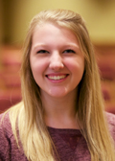 | Megan Rosenau (Class of 2016) is excited to work on the hair and makeup crew for her first time. She previously appeared onstage in A Midsummer Night's Dream (Titania) and Thoroughly Modern Millie. She thanks both Pschirrer and Maguire for their continual support in this department.
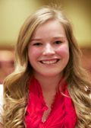 | Katlynn Souers (Class of 2016) is excited to be working as House Manager for Into the Woods. She crewed LC’s The Dining Room, and appeared in Opening and Closing Night and Seussical. She will also appear in Kelly the Destroyer this spring. She thanks Pschirrer and Maguire for their continual support for this department.
 | Isabella Weiand (Class of 2016) has crewed LC's productions of The Little Mermaid, Thoroughly Modern Millie, Noises Off! and A Midsummer Night’s Dream. She is looking forward to being a part of crew for Into the Woods this year.

