LEWIS & CLARK TIGER DRAMA

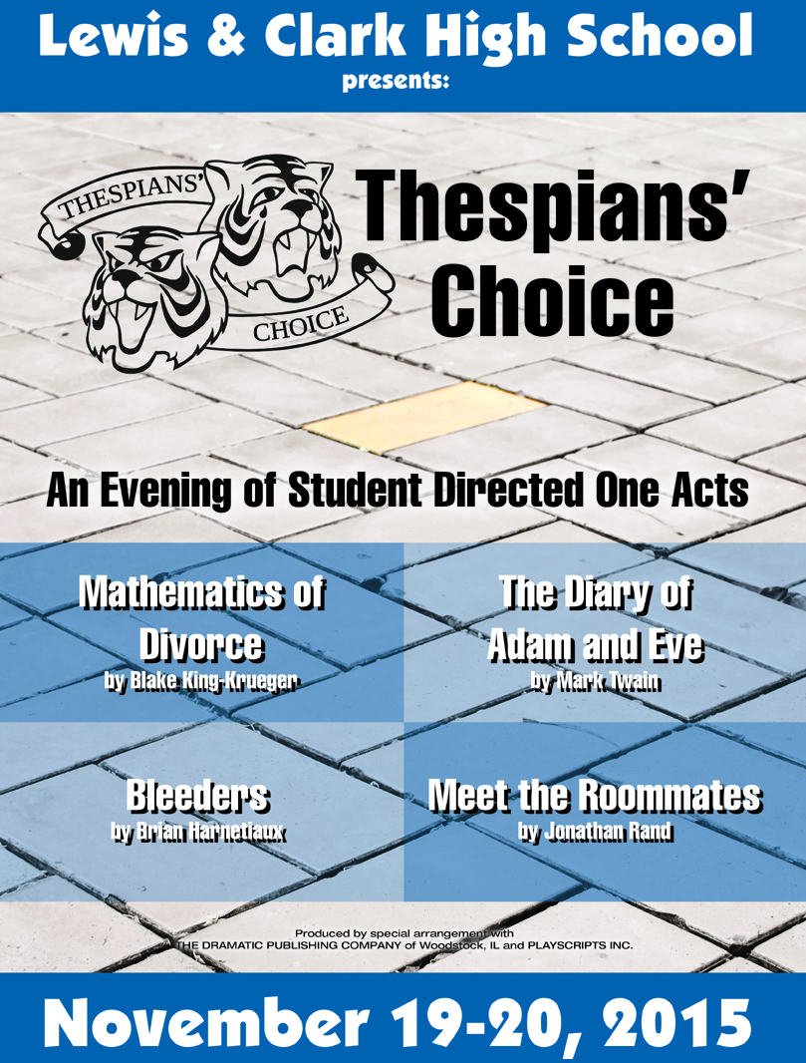

WWW.TIGERDRAMA.COM
REVISIT OUR PAST SEASONS AT www.tigerdrama.com

 |  |  | 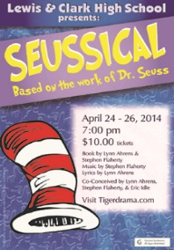
 |  |  | 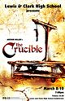
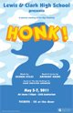 | 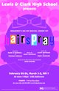
 |  |  | 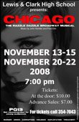

SPECIAL THANKS
Blake King-Kruger | Brian Harnetiaux
STAGE Board & Parents | Cassie & Jason Heppler
Seth Murphy | Anna Maguire
Richard Maguire | Genevieve Palmer
Tom Bowers | LC Business Office

2015-2016 TIGER DRAMA
PRODUCTIONS
Closing
Night
February 25-27  March 3-5, 2016 | April 21-23, 2016 | June 2, 2016

ILAN

Very proud of your hard work and dedication the past four years. It has been amazing to see you accomplish so many things along the way! I am truly proud to be your twin brother!

Way to go, bro!
Isaiah

LEWIS & CLARK

TIGER DRAMA

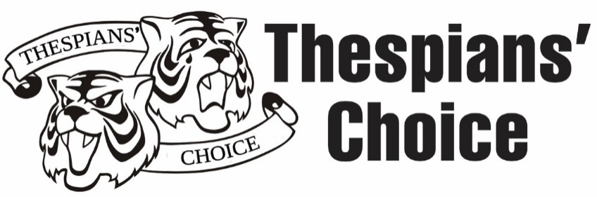

Suzanne Maguire - Mentor Director
Greg Pschirrer - Production Supervisor

ACT I
Mathematics of Divorce by Blake King-Kruger
Director - CaraLee Howe

Diary of Adam & Eve by Mark Twain
Director - Chloe Forsberg

*There will be a 15 minute intermission between Acts.

ACT II
Bleeders by Brian Harnetiaux
Director - Ilan Hernandez

Meet the Roommates by Jonathan Rand
Director - Tailer Englehart-Grotte

Program Design | Poster Design | Scene Design/Construction
Theresa Meyer | Seth Murphy | Stagecraft Class
Headshots |  | Videographer
Scott Martinez |  | Richard Maguire

Produced by special arrangement with
Dramatic Publishing Company & Playscripts, Inc.
THESPIAN’S CHOICE

THESPIANS’ CHOICE begins a new Tiger Drama tradition where our inducted Thespians have a voice in our season selection process. To inaugurate this tradition, we chose to do student directed one act plays. When our 2015-2016 season was revealed last spring, students were told that they would have the opportunity to apply to be student directors and submit one act plays for potential production. Over the summer, many students read scripts and narrowed down their lists of possibilities. Two students even met personally with their chosen playwrights. This fall, students submitted plays and applied for director positions.

New experiences for these novice directors included the audition and casting process, rehearsal scheduling, directing their peers, managing a creative team, and giving notes to their actors. In addition to the normal directing challenges, our student directors also guided 14 students who have never been in a Tiger Drama production before. We are excited for the level of new student involvement in a production like this! Thank you, as always to parents, guardians and our Tiger Drama community for continued support of educational theatre!

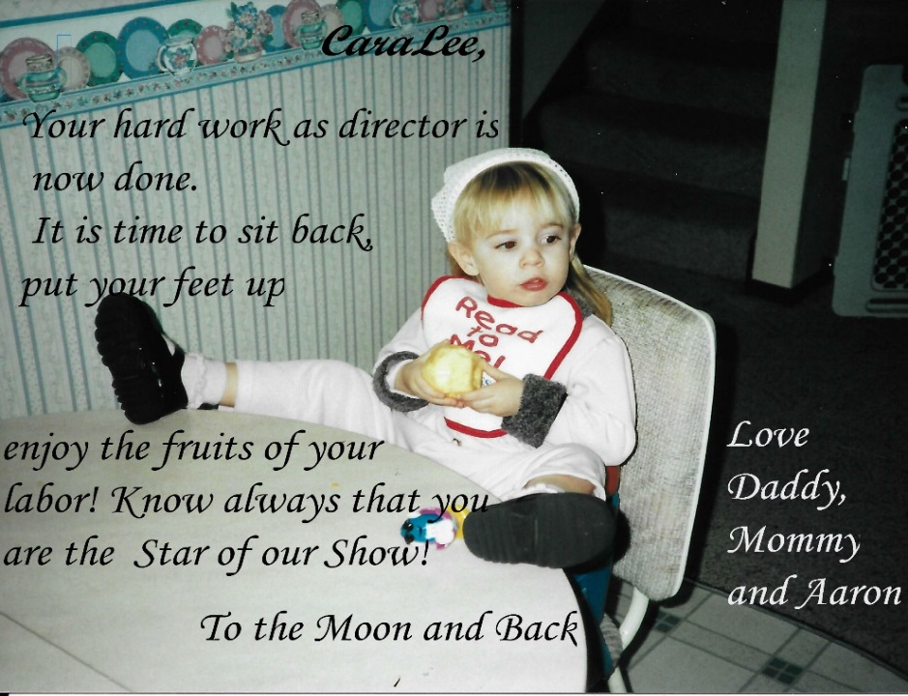
CaraLee,

TIGER ROARS FROM
FRIENDS AND FAMILY

So proud of you Alexis Hinkle! Love Gram |  | Bailey, "Accept no one's definition of your life. Define yourself!, "Harvey Feirstein…Break a leg! xoxo Quincy
Erin, we are so proud of you! Have fun and enjoy every moment! Love Dad, Mom, Derek, and Kevin
 |  | We love you Hannah, "Smooch" Summers. So glad you’re having this experience! Love, Mom, Dad, Finley, Clara, & Willa
Ilan, from your loving fan base in Montana!- Grampa & Grama Strosky
 |  |  |  | Good job Megan! We love you! Mom and Dad
A Tiger Shout Out to Noel, our amazing son! We couldn't be more proud of you! Love, Mom, Dad & Fam |  |  | Eli, our character on and off stage- Good luck, with applause! Mom and Dad
Ilan, Congrats on your directorial debut. I'm so proud of you! Love,G'ma | CaraLee, I really "lilac" you! Can't wait to see your show! Quincy |  |  | Ilan, Another day, another destiny! Congrats on your directorial debut! Tia
WHO’S WHO IN THE CAST

Meet the Roommates

Eli Svoboda (Class of 2019) has been in several Spokane Civic Theater productions including How I Became a Pirate (Sharktooth) and The Hobbit. He dedicates this performance to the statue his father played in The Music Man.
ABOUT THE
MENTOR DIRECTOR

Suzanne Maguire (Mentor Director) is glad to be entering Year 5 working with Tiger Drama. She holds a Bachelor’s degree in Speech Communication and Theatre from Northern Arizona University with teaching endorsements in both subjects. Favorite productions as an actress include Bus Stop, Barefoot in the Park and Other Places. Memorable directing experiences include last year’s production of Into the Woods and her first LC production of The Crucible. Thanks always to supportive husband, Richard & kids (Brennen, Anna & Elliott).

ABOUT THE
PRODUCTION SUPERVIOR

Greg Pschirrer (Production Coordinator and Technical Supervisor) is enjoying his 13th season as Drama Director where he has helmed over 35 productions. As a performer, he appeared in: The 25th Annual Putnam County Spelling Bee, Forever Plaid, Cats, and West Side Story. He holds a BA in History (Gonzaga) and an MA in Theatre Production (CWU). Assorted LC productions include: In the Heights, Miss Saigon, Chicago, and Thoroughly Modern Millie. He dedicates this season to his parents for helping ‘pave the way’ to a fulfilling artistic career.
ABOUT THE DIRECTORS

Tailer Englehart-Grotte* (Class of 2016) is excited to kick off her senior year by directing! This process has been wonderful and she is excited to be a part of the first Thespians’ Choice! Tailer was most recently seen as Darzee in Kelly the Destroyer vs the Springfield Cobras and Philostrate in A Midsummer’s Night Dream! She would like to thank her family for supporting her, and her grandma for giving her rides every day!
Chloe Forsberg* (Class of 2016) Chloe is very excited to be directing for the first time! She has stage managed 3 shows for LC, and will be stage managing How to Succeed in Business Without Really Trying this year. She would like to thank Pschirrer and Maguire for giving her these wonderful opportunities, and would also like to thank her family for supporting her throughout her high school drama career.
Ilan Hernandez* (Class of 2016) is honored to direct for the first time. He is grateful to have worked under the mentorship of Maguire throughout this eye-opening process and is exceedingly proud of his cast for all their work. He thanks Bryan Harnetiaux for his advice and wisdom about the show. Special thanks to Pschirrer, Theo Mynka, as well as his amazing, supportive family at home and in LC Tiger Drama.
CaraLee Howe* (Class of 2016) is thrilled to be directing for the first time. She has been involved in six Tiger Drama productions in the past. She thanks Pschirrer and Maguire for this opportunity and her family and friends for their constant love and support.
WHO’S WHO IN THE CAST

Meet the Roommates

Bailey Heppler* (Class of 2017) is so excited to be working with her classmates on student directed one acts, in both onstage and off. Most recently she has been seen in Kelly the Destroyer (Indigo), and Midsummer (Puck). She thanks Pschirrer and Maguire for all of the amazing opportunities they give to this department.
Emma Lyons* (Class of 2016) Emma is elated to be on the LC stage again. She usually can be found in the light booth, but has been in Kelly the Destroyer (Bee) and Seussical (Thing 2). Emma is highly involved with the international Thespian honor society, is an honor thespian and a Washington State Thespian Officer. She plans to study lighting design in college.
Maddy Murphy* (Class of 2018) Past experience at LC include Into the Woods crew, and Opening Night 2015, but she has also performed in over twenty shows since the age eight. She is in her first year of Advanced Drama, and her second year of Advanced Chamber Choir. She thanks Tailer Englehart-Grotte for casting her, and her wonderful fellow cast members for sharing their talent and love of theater with her.
Nemico Tagalag (Class of 2019) is a fun loving, positive and accepting person. He is very excited to play Todd. He is used to playing narrators and memorizing large sections of lines. He can expressively show emotion and he is ready for a challenge, always open to listen to his directors’ wisdom.
WHO’S WHO IN THE CAST

Meet the Roommates

Bri Barrick (Class of 2018) is super excited to be in her first LC production! She has previous experience with CYT Spokane and would like to thank Tailer Englehart-Grotte for this amazing opportunity and her parents for their continued support.
Noel Case* (Class of 2018) loves drama. Prior to high school, he starred in Bugsy Malone, Annie, and Shrek the Musical. Last year he qualified for state in the solo musical category and became a Thespian at Opening Night 2015. He is excited to play the role of Tommy in his third LC production, after A Midsummer Night's Dream and Opening Night 2015.
Bethany Daniel (Class of 2018) is so excited to play every actor's dream role: a three year old girl. She's a proud member of the LC Tiger Drama Department, and enjoys cuddling with her puppies and kitty in her spare time. She'd like to dedicate her performance to her wonderful friends and family.
Adonis Fernandes (Class of 2018) has previously been seen as “Grandpa” in A Kid’s Night and has some experience with theatre from attending the Venture Theatre in Billings, Montana for three years. He is very excited to perform in this production because it is his first LCHS Drama performance.
THESPIANS’ CHOICE
ONE ACTS CREW

House Manager…………………………………….….Jordan Edwards
House Manager………………………………………..….Patrick Lynch
Front of House………………………………………….Beakal Yimam
Hair/Makeup/Costumes Crew Head……………Harley Haberman
Costumes………………………………………….………Hannah Lister
Costumes……………………………………….…….………M.E. Martin
Backstage/Props Crew Head……………Miranda Anthony Miller
Backstage………………………………….…….………Tatyanah Edgar
Backstage………………………………….………..………Sonya Larson
Props………………………………….…….………Sophia Anne Moore
Props…………………………………….…….………Kaylee Westbrook
Sound…………………………………….……………...………Eric Boose
Lighting Crew Head…………………………………Madeleine Feola
Lighting…………………..……………..……………Hannah Summers
BECOME A TIGER DRAMA PATRON

If you have the means and the heart to share, please consider being a financial sponsor of LC Tiger Drama. Examples of what donations sponsor:
- $50 helps sponsor guest teachers who are experts in their fields (stage make-up, stage combat, lighting design, etc.).
- $100 helps us add scripts to the theatre library, a valuable classroom resource.
- $250 helps us maintain or replace our stagecraft supplies (tools, appliances, lumber, etc.)
- $500 helps us maintain or replace lighting equipment.
- $1,000 helps us pay for the rights for a play.
- $2,500 helps us pay for the rights, scripts, & music.
- $5,000 helps us maintain or replace parts of our flies system (curtains, rigging, etc.).

Interested in participating or becoming a Tiger Drama Patron?
Email tigerstagegroup@gmail.com
WHO’S WHO IN THE CREW

Miranda Anthony-Miller (Class of 2018) is excited to be assisting with the rest of the crew. She hasn't performed on stage before, but has worked on previous shows and enjoys helping backstage. Although she doesn't appear on stage, she loves the theater and she hopes to continue to participate in theatre throughout high school.
Eric Boose (Class of 2017) is excited to be involved with an LC Drama production for the first time. He would like to thank Pschirrer and Maguire for the opportunity, and hopes to be a part of Tiger Drama performances again in the future.
Tatyanah Edgar (Class of 2018) studied voice at the Civic Theatre. This is her first time being involved in a LC production as well as her first time on crew. She is excited to be a part of this production and thinks it will be a great experience. Big thanks to Pschirrer and Maguire for this opportunity!
Madeleine Feola (Class of 2018) plays violin in the LC chamber orchestra and won first place in LC’s poetry slam last year. She enjoys reading and painting in her spare time. This is her second show with LC, after working on crew for Opening Night 2015.
WHO’S WHO IN THE CAST

Diary of Adam and Eve

Megan Rosenau* (Class of 2016) is thrilled to be the snake in The Diary of Adam and Eve. She previously has appeared on the LC stage in A Midsummer Night's Dream, Thoroughly Modern Millie, and both Opening and Closing Night. She would like to thank Pschirrer and Maguire for their continual support in this department, her family, and Chloe Forsberg for the opportunity.

WHO’S WHO IN THE CAST

Bleeders

Tyese Chumov (Class of 2016) is elated to be acting as Helen in Bleeders. She worked backstage for LC’s The Little Mermaid, The Dining Room, Noises Off and others! She plans on attending EWU as a Psychology Major. She dedicates her performance to her loving, talented family as well as Kira J, Kaitlyn, and Garrett who have helped with her role.
Ethan Goins* (Class of 2018) is excited to be a part of his third LC tiger drama production. He is so happy that this department has welcomed him in with open arms and is looking forward to his future here. Ethan would like to thank his mother for being so supportive of his interests.
Evan Saggau (Class of 2016) had a small part in educational films for children, and made his stage debut in Opening Night 2015. He is very excited for his second stage appearance, and thanks Pschirrer for the encouragement to continue his path in the department. He dedicates his performance to all of his loved ones.
WHO’S WHO IN THE CAST

Mathematics of Divorce

Libby Palmer (Class of 2018) is excited for her first Tiger drama production. Outside of Drama, Libby serves as a captain for the Lewis and Clark debate team. She would like to thank Pschirrer, Maguire, Mr. Mick, and all of her teachers for helping her get to where she is. She would also like to thank her family for their continuing support and unwavering love.
Claire Woodard* (Class of 2018) is very excited to be a part of Lewis and Clark High Schools' first year of student directed one acts, and to be in the first staged production of Mathematics of Divorce. She would like to thank Pschirrer, Maguire, and the director, CaraLee Howe, for the opportunity.

WHO’S WHO IN THE CAST

Diary of Adam and Eve

Erin Chaves* (Class of 2018) is absolutely thrilled to be playing Eve! Recently, she has been seen in SCT's Tom Sawyer (Huck Finn), Closing Night, and Opening Night. Erin is a huge lover of the arts and is so happy to be involved with LC's wonderful theater department. She would like to thank Chloe Forsberg for such an amazing opportunity!
James Hogstad* (Class of 2016) is enthusiastic about playing Adam in The Diary of Adam and Eve and has been seen in A Midsummer Night's Dream and Thoroughly Modern Millie at Lewis & Clark High School. He would like to thank his director Chloe Forsberg, Maguire, and Pschirrer for the opportunities.
WHO’S WHO IN THE CREW

 | Harley Haberman* (Class of 2016) made his makeup artist debut in A Midsummer Night's Dream since then he has work as a freelance makeup artist in Spokane. He has had the privilege of being the makeup artist for numerous music videos, short films, and theatrical productions including: Into the Woods, Kelly the Destroyer vs. the Springfield Cobras, and Suessical.
 | Sonya Alison Larson (Class of 2016) has taken every art class that Lewis and Clark has to offer and also takes art classes outside of LC. She intends to go to PLU to get her bachelors in education so she can join the peace corps. This is her first year being involved with the drama program and stagecraft and she is eager to be involved.
Photo Not  Available | Hannah Lister (Class of 2019) is excited to work backstage in customs for her first L.C. production. Previously, she was cast in the CYT productions of Shrek and Peter Pan. She has also danced at the Dance Center of Spokane since she was three. Hannah really enjoys theatre and hopes to participate in L.C.'s drama program in the years to come.
 | Mary "M.E." Martin (Class of 2018) is excited to be a part of crew for her first LC production. She enjoys singing, reading and acting, and has been fascinated by the makings of a theater production since she was young. This is also her second year of singing with the LC Choir. She plans on continuing with theater during her college years.

WHO’S WHO IN THE CREW

Sophia Anne McFarland Moore (Class of 2019) participates in the LC Drama club and is trying to start a Ukulele club. She enjoys writing music, going outside, hangout with friends, and preforming in theater productions like: Opening Night 2015 and The Importance of Being Earnest (Civic Theater). She has taken voice and guitar at Stacy De & Co when she lived in Illinois and is thankful to be given this opportunity.
Eric Rorholm* (Class of 2017) is thrilled to be stage managing after appearing in shows including Fiddler on the Roof and Catch Me If You Can at Spokane Civic and Into the Woods at LC. He participates in Track & Field and has qualified for state in DECA and National Thespian Festival for scenic design. Eric thanks his friends and family of the theatre community for their continued guidance, love, and support.
Hannah Summers (Class of 2018) is excited to expand her theatre experience in her first technical position. Previous productions include St. Mark’s I Never Saw Another Butterfly and Our Town as well as Lewis and Clark’s A Midsummer Night’s Dream. In her free time, she enjoys playing soccer and tennis and spending time with friends. She looks forward to being involved in drama throughout her high school career.
Kaylee Westbrook (Class of 2018) is so excited to work with the Tiger Drama department as a crew member for the first time. She was involved in LC's 2015 Opening Night and The Secret Garden at TAC (Maid Jane). She cannot wait to work more with the department and would like to thank her family and friends for putting up with her theatre obsession.

WHO’S WHO IN THE CAST

Mathematics of Divorce

Daria Baer (Class of 2019) is excited to be playing Alex in The Mathematics of Divorce. She thanks Cara Lee, Maguire, and Pschirrer for this amazing opportunity. Although this is her first Tiger Drama performance, she has performed in many Civic Theatre plays, and played Flute and Pyramis in a backyard performance of A Midsummer Night’s Dream. Later in life, she hopes to publish many of her poems, and stories.
Alexis Hinkle (Class of 2016) is thrilled to be in her first LC production. She thoroughly enjoys singing and playing the violin. She would like to thank Caralee Howe and Pschirrer for this opportunity and dedicates her performance to her supportive family and friends.
Sebastian Greer (Class of 2016) plays club lacrosse and competes on LC's CyberPatriot team. This will be his first LC production. Interests include playing guitar and listening to music. He hopes to attend a four-year college next year. He thanks Pschirrer for his support an encouragement and would like to dedicate this performance to Steven Wilson.
Brittany Mendoza-Pena* (Class of 2016) is excited to be a part of this new Tiger Drama experience! Previous Tiger Drama appearances include In the Heights (Nina), Thoroughly Modern Millie (Ensemble), and Into the Woods (Little Red). She is thankful for the continuous support from the community and her loved ones.

*Denotes member of International Thespian Troupe 6356

THESPIANS’ CHOICE
ONE ACTS CAST
MATHEMATICS OF DIVORCE:
Alex…………………………………………………………….Daria Baer
Kat………………….……………………………………….Libby Palmer
Maria……………………...…………………….Brittany Mendoza-Pena
Charlotte………………………..……………………….Claire Woodard
Parent Role Male………………….……….…………….Sebastian Greer
Parent Role Female…………………….………………….Alexis Hinkle
DIARY OF ADAM & EVE:
Adam………………………………….………………….James Hogstad
Eve…………………………..…………….………………….Erin Chaves
Snake………………….…………….………………….Megan Roseanau
BLEEDERS:
Gar…………………….…………….……………………….Ethan Goins
Helen…………………….……………….……………….Tyese Chumov
Vince………………………….…………….……………….Evan Saggau
Non-Speaking Roles:
Patron 1……………………….…………………………….Iaine McKay
Patron 2………………….…………….……………….Sebastian Greer
MEET THE ROOMMATES:
Tom……………………….…………………..……………….Eli Svoboda
Tommy……………………….…………...…………………….Noel Case
Jen……………………….……………………..……………….Bri Barrick
Jenny……………………….…………..………………….Bailey Heppler
Patrick……………………….……………………………….Iaine McKay
Todd……………………….…………………………….Nemico Tagalag
Emelyn…………………….…………………………….Maddy Murphy
Brenda……………………….…...………………………….Emma Lyons
Brian……………………….………………………….Adonis Fernandes
Mike……………………….………...………………………….Cole Mack
Sharon……………………...…….……………………….Bethany Daniel
WHO’S WHO IN THE CREW

Beakal Yimam (Class of 2018) is excited to be on her first crew and usher for Thespians’ Choice. Beakal has been an honor roll student since junior high. She enjoys sports, outdoor activities, and is planning on going to WSU after graduation.

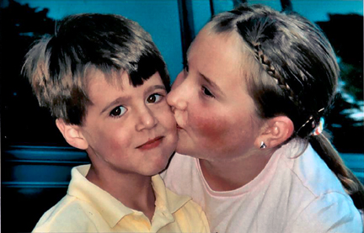
Jamie,
We’re very proud of you! From two of your greatest fans.
Kirsten & Mom
Chloe Jo,

We are so very proud of you!!!

Your growth from grade school theater camp to your directing debut is awesome. You have worked very hard to achieve your goals!

“How little a thing can make us happy when we feel we have earned it?” – Mark Twain, The Diary of Adam & Eve

Your entire family!!

